Pfizer Allergan scrap $160B deal after U.S. tax rule.

http://www.reuters.com/article/allergan-ma-pfizer-idUSL2N1781FF
Pfizer looking to merge with Allergan in order to complete an inversion by taking advantage of Ireland’s comparatively smaller tax rates.

Obama has been pushing against big deal inversions, making this a big win for his administration.

Pfizer not willing to renegotiate amidst passing of this treasury legislation, even with previous synergies of lower tax rates no longer achievable.

"While the Treasury Department's actions will make it more difficult ... to exploit this particular corporate inversions loophole, only Congress can close it for good," Obama said.

Besides Pfizer-Allergan, deals that could be affected by the new rules include the proposed $16.5 billion merger of Johnson Controls Inc with Ireland-based Tyco International Plc

Allergan shares were down 15.4 percent at $234.94 in the busiest trading day in company history. Pfizer shares rose 2 percent to $31.33.

Pfizer, which announced the deal in November, has said its tax rate would drop to about 17 or 18 percent after the deal, from around 25 percent. That would represent more than $1 billion in annual cost savings.

Shares of M&A advisory firms, meanwhile, tumbled in response to the new U.S. inversion rules. The S&P 600 Investment Banking & Brokerage Index lost 2.9 percent, M&A advisor Evercore Partners fell 4.7 percent, while Greenhill & Co was down 4.5 percent.

Treasury said it will impose a three-year limit on foreign companies bulking up on U.S. assets to avoid ownership limits for a later inversion deal. Allergan's key deals in the prior 36 months include the $66 billion merger with Actavis Plc and the $25 billion purchase of Forest Laboratories.

If Pfizer does not acquire Allergan's new, fast-growing medicines, Pfizer will need to look for other companies with attractive products, such as U.S. drugmakers Biogen Inc , Regeneron Pharmaceuticals Inc and AbbVie Inc , said Raghuram Selvaraju, managing director of brokerage H.C. Wainwright.

Morningstar analyst Damien Conover said if the deal collapses, Pfizer will likely move up its decision on a key business strategy - whether to sell or spin off its hundreds of generic medicines.
Pfizer had planned to make a decision by 2016 whether to split off its generics, but delayed the decision until 2019 after announcing its merger with Allergan. Conover said the decision could be moved to late 2017 or 2018.
Jeff Jonas, a portfolio manager at Gabelli funds which owns Allergan shares, said Allergan stock was falling as merger-related investors sold out, but that Allergan as a standalone company is attractive.
"They've been very successful as an acquirer over the years, making smart deals, not overpaying for them, integrating them well and making them work. They just get back to that," Jonas said. He said he thinks Allergan is worth about $250 per share
https://imaa-institute.org/statistics-mergers-acquisitions/
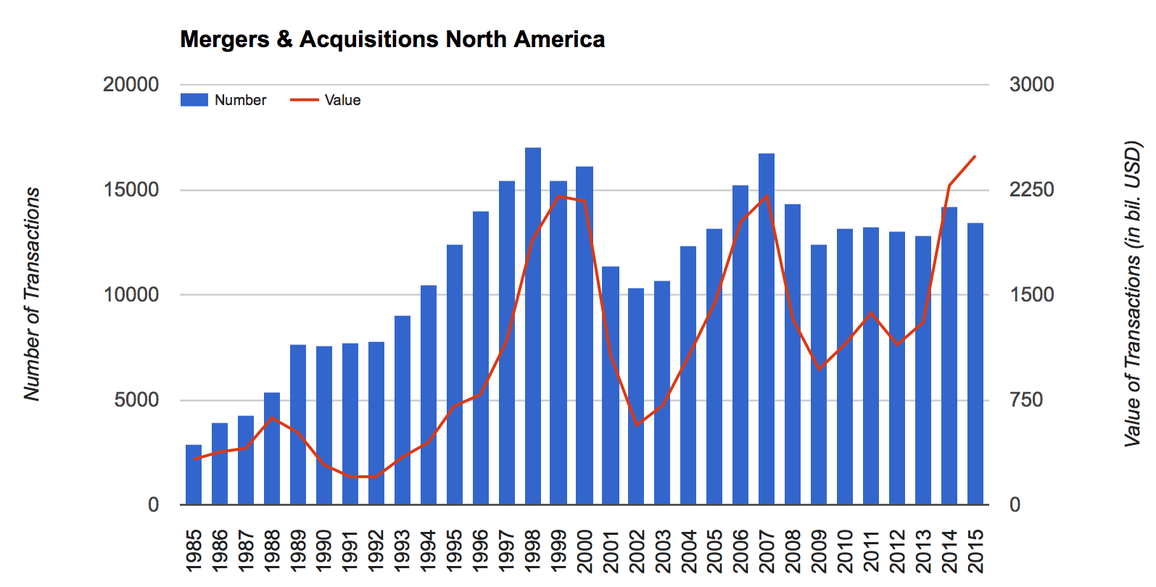
http://www.bloombergview.com/quicktake/tax-inversion
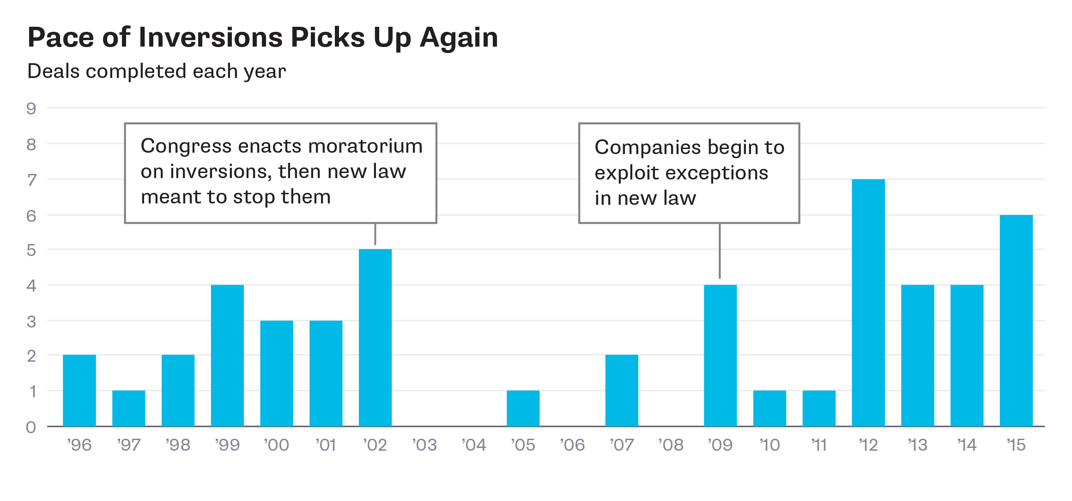
The U.S. corporate income tax rate, 35 percent, is the highest in the developed world. The U.S. is also one of the few countries that makes its companies pay that rate on all their worldwide income — although they can defer the bill on profits attributed overseas until they bring the money home

The Treasury’s new tightened rules have made inversion deals less attractive, but the Obama administration has warned that only legislation can stop them completely. Neither Democrats nor Republicans like inversions, but they disagree on what to do about them. Republicans call them the inevitable consequence of a flawed tax system, and say the only solution is a full revamp of the tax code, including lowering the corporate rate and limiting taxes on foreign profits. Although some Democrats agree on the broad outlines of a corporate-tax revision — Obama’s 2016 budget had called for lowering domestic and foreign rates — the parties disagree on so many other things that there’s little chance that a big tax bill will pass Congress any time soon. The deadlock means that more and more executives will embrace a do-it-yourself fix.

