Activision  NASDGS: ATVI – bought at 35.40 |  |  | Analyst:  Sector: |  | David Itoafa  Toys & Games
Buy |  |  |  | Price Target: $42.55
Key Statistics as of 11/23/2016 |  |  |  | Catalysts:
Market Price: $36.84  Market Cap: $27.66B  52-Week Range: 26.49-45.55  Beta: 1.01 |  |  |  | - Short-term ( within 3 months): Q4 Earnings Call 2 February 2016  - Mid-term (1 to 2 years): Expansion of Mobile Gaming Market  - Long-term( over 2 years):Increased Popularity of E-Sport and virtual reality possibility in future

Company Description:
Activision Blizzard Inc. has been a staple in the industry and has been publicly traded under the ticker ATVI since the company became independent from Vivendi games in 2013. The company was first founded in 1979 and has had its headquarters in Santa Monica California from the date it was established The company operates through 2 main segments Blizzard Entertainment Inc., and Activision Inc. After the acquisition of King Digital Entertainment earlier this year the Activision sector delivers online games through retail and digital online channels. These channels consist of personal computer, mobile and table devices that target consumers of all ages. The Blizzard Entertainment Inc. segment focuses on online role playing games like World of Warcraft, StarCraft, Hearthstone, ETC. The final component operations at Activision Blizzard E-sport and media networks segments the first focuses on the E-sport Industry and the second on Media contents like the movie that was recently released Warcraft.

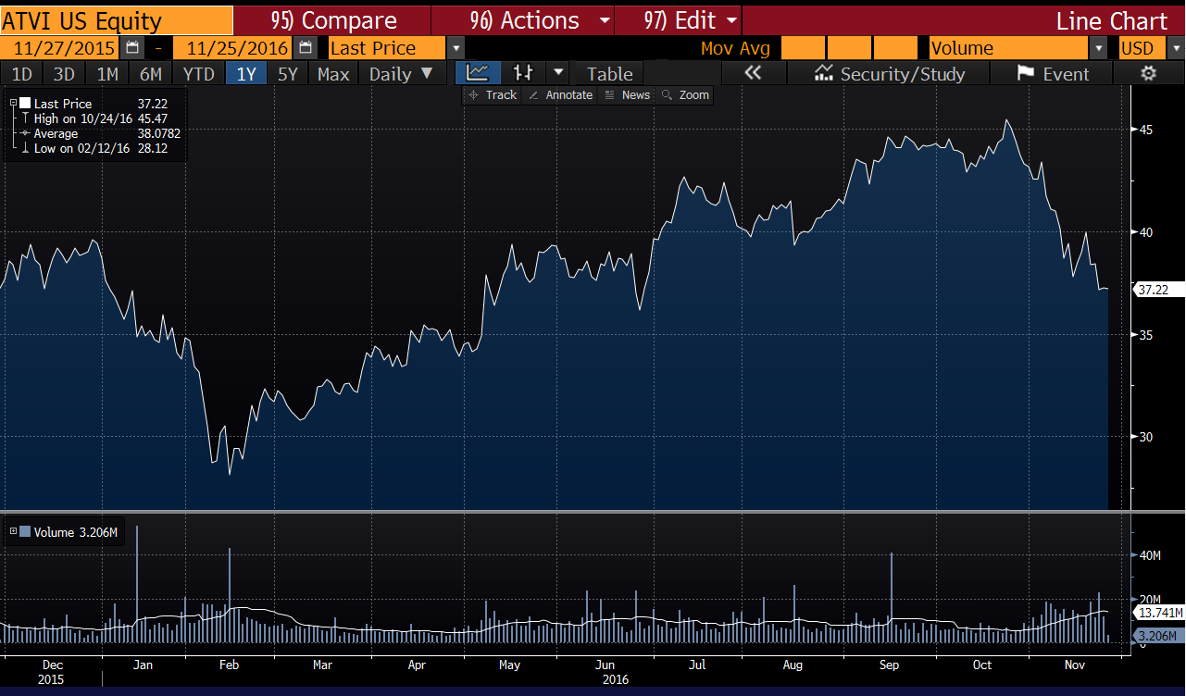

Thesis
- Expansion with the company offering More Protection and many risks explained in their most recent 10-k have diminished
- Gaming Market continues to grow and Activision is best positioned to take advantage in the future.
- Virtual Reality / Augmented Reality Potential for future could have similar effect of Nintendo’s Pokémon Go.

Business Model
Blizzard Inc.’s Business model is unique and compelling compared too many of its competitors. In order to sustain revenue growth the company must maintain its current customer base from the various games released over the past 15 years and acquire new customers. In order to achieve these goals the company focuses on three pillars that have helped them become very successful throughout their years at the top of the industry. The company focuses on expanding audiences, Deepening Engagement, and providing opportunities more player investments. The first pillar of expanding their audience will convert to stronger revenue growth in the future.
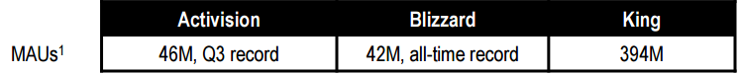
Source: Q3 Earnings Call
The main reason Activision Inc. will be successful in the future will be due to its ability to sustain these customers. Video game habits on mobile, PC, and Console carry over from childhood to Adulthood meaning more potential revenue for Activision because it has established itself on every platform possible. Since the company has been along for so long revenue growth many analysts believe it will deteriorate over time, but since they have acquired new companies that have massive client bases in emerging markets therefore this will not be the case for Blizzard Activision Inc. The second pillar focuses on customers not only buying the product, but keeping them involved and excited about games in the long run. Blizzard Activision Inc. has been able to make keep consumers hooked to their games and continued this trend last quarter by having over 10 Billion in hours played by all users among all platforms a record high. This pillar may seem irrelevant, but since their most important pillar of providing opportunities for more player investment is dependent on deepening engagement these numbers show their content is appealing to users. 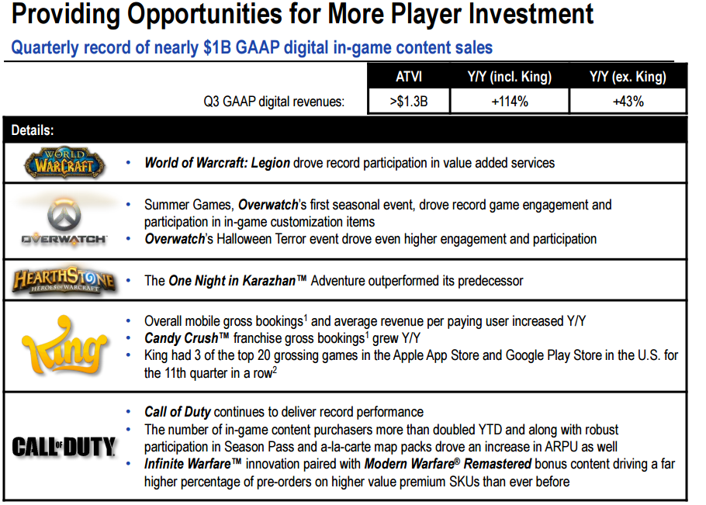
Source: Q3 Earnings Call
Since more people are playing their games for more time the company is generating more money from customers purchasing in game content. This enables Activision Blizzard Inc to maintain revenue even after a game has been launched.
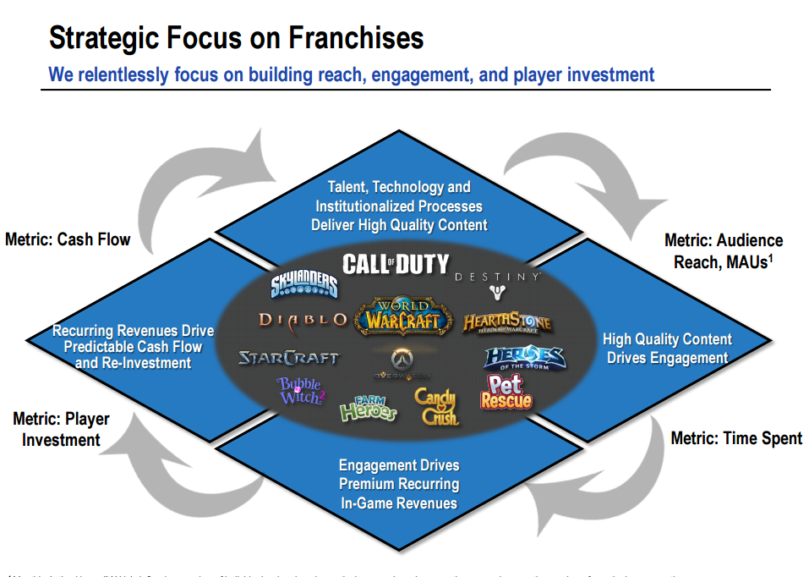
Source: Q3 Earnings Call

This business model is the reason why Blizzard Actvision Inc, has beat estimates of GAAP EPS for every quarter for the past 2 years. The model will also enable them to tap into emerging future markets translating to more revenue in the next quarter and fiscal year.

Emerging Markets
Another main component to the future of Activision is that gaming has yet to be fully integrated into culture. There is still room for markets to expand in two specific areas that ATVI control: the first being gaming on all platforms and the second being people watching professional gamers. 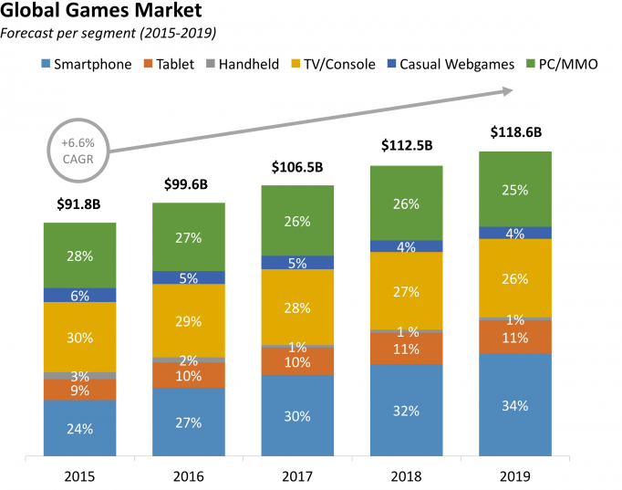
Source: Newzoo

The graph demonstrates how each sector of the global gaming market will do in the future. ATVI has a substantial amount of control in the PC, TV/ Console, and Smartphones, and tablets. Mobile gaming, which includes smart phones and tablets is expanding the most and since Activision has recently acquired KING, entertainment they are aware of the potential shift to mobile gaming in the future. With this acquisition they own all rights to the mobile game Candy Crush and with this producer could capture more market share in the future. Since Blizzard and Activision own two very popular games similar to Pokémon: World of Warcraft and Call of Duty. There is a possibility they create a mobile app similar to Pokémon Go utilizing augmented reality in the future. This move awoke Nintendo from the dead of gaming and this type of maneuver could propel ATVI even higher. Although management has stated that they do not intend to go into virtual reality and augmented reality in the near future, they did state that they are monitoring and are very optimistic about the potential of virtual gaming. The second market that is starting to grow more and more is the E-Sport Market

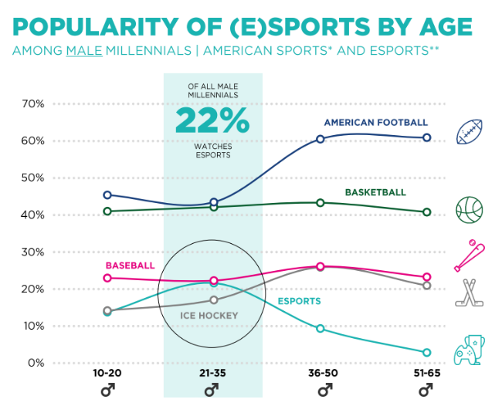

Source: Newzoo

Blizzard Activision have also recently acquired MLG a platform where various people can watch professional gamers play their favorite games at tournaments. Male millennials watching electronic sports have surpassed ice hockey are on par with Baseball at 22%. There is no doubt that once millennials get older and the next generation will have similar if not a higher percentage of male viewers. Since this market is also emerging and will continue to grow in popularity ATVI will be able to capture more viewers on their MLG platform. The reason why ATVI will thrive so much with the expansion in these markets is because it owns the majority of games that are popular at this moment of time and have enough power to create games that attract even more users in the future.

In Game Advertising
Leading on from emerging markets in the most recent earnings call ATVI has discussed that they have begun advertising their Activision Blizzard INC, games in their mobile games like Candy Crush. As shown in the earlier diagram King Entertainment have roughly 400M MAU’s that are now being targeted by Activision with advertising that is essentially free for the company. Certain analysts believe that there is a $500 million dollar potential opportunity with in- game advertising for ATVI, which the majority of wall street has yet to factor into their price and revenues for future years. One of the main pillars discussed by the company in their most recent earnings call is increasing the number of users of their products. Therefore, CEO Bobby Kotick knows that the advertising in these games cannot become annoying, but has huge potential since none of their competitors have access to these active users. This will give them a competitive advantage over competitors like EA and generate more users in the future.

CEO New Pay Deal
Activision Blizzard have recently reached a new contract with CEO Bobby Kotick who has been at the helm of Activision for the past 25 years. This is a major positive for the company because he has lowered his salary from $2.4 billion to $1.8 billion means he cares more for investing in the business then his personal life. He does stand to make $56.3 million in shares for the next three years if the company achieves all objectives set out to achieve. This could possibly be due to soft guidance for the holidays, but could also mean that the CEO has belief in the company achieving its financial goals in the future. The company has expanded under Bobby Kotick renewing his contract means the board is happy with the direction that the company is headed in.

Valuation
Many analysts are skeptical of blizzard due the substantial amount of debt that they have incurred in the last three fiscal years.
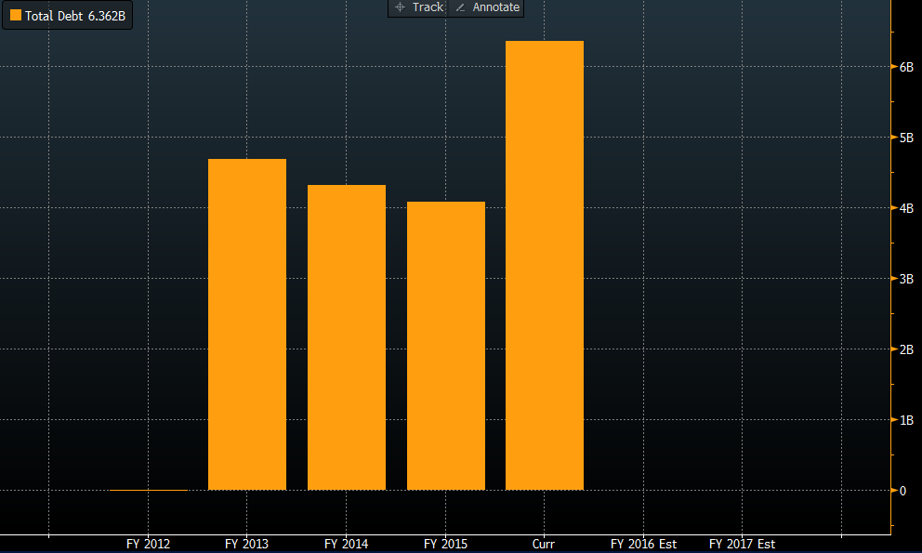
Source: Bloomberg

In the past year total debt has reached roughly 6.3 billion dollars and if revenue growth does not continue the company is subject to major risk in the future. However, a point worth noting is that in case such a tragedy does fall upon ATVI they are still better positioned then there competitors in terms of refinancing.
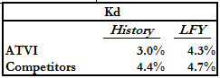

These are the only potential risks associated to ATVI and along with softened guidance’s for the holiday season has made the price drop slightly. This means that the stock at this moment is undervalued and has a reasonable point of entry. Along with a very impressive business model with clearly defined goals and objectives that have been proven effective in previous years means the company is on the right track.
Source: Bloomberg

The amount of cash from operations has doubled the last fiscal year and their capital expenditure remains fairly low with revenue growth increasing every year. Although analysts have not been impressed with recent quarter’s earnings call there is no doubt that ATVI his hitting their fiscal year goals consecutively

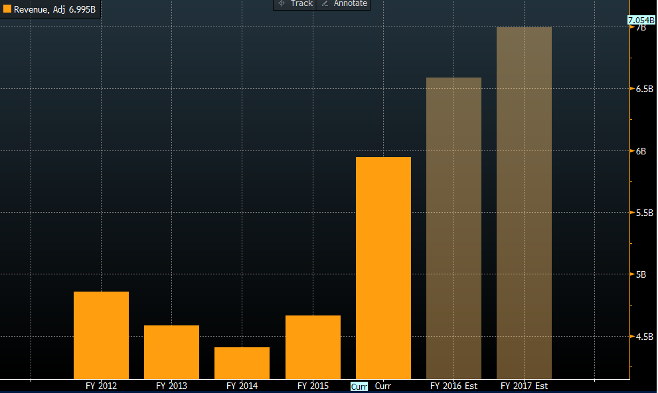
Source: Bloomberg

With a projected revenue of roughly $7 billion in 2016 there is no doubt that revenue growth is not a worry for ATVI in the future and they will be able to manage the substantial debt they have incurred. In addition to these projected revenue numbers have not accounted for the company’s business model, emerging markets in game advertising and the CEO’s new contract.

Conclusion
The future looks bright for ATVI due to revenue growth potential in the future and analysts underestimating certain aspects of the business. The stock is not discounted at this time, but due to a recent drop in holidays this is a good entry point for the stock.

- Entry point range: $36- $37.50
- Price Target: $42.55
- Target 1 year return: 10%-20%

