Project | Trading Insights – 7 Ways to Adapt for Volatile Markets
Client | Adrianne Muscanere
Date | November 4, 2015

Existing Article

N/A

Keywords
Volatility, pullbacks, uptrend

Trading Insights Homepage Assets

Thumbnail Copy (right rail/homepage tab/carousel –bottom of article)
Don’t Be Frightened By Volatility
Learn 7 ways to adjust for a volatile market

Homepage Hero/Carousel Copy (60 character limit)
7 Ways to Adapt for Volatile Markets

Main Article Assets

Hero Image

Hero Image (Thumbnail)

Hero Images Title
7 Ways to Adapt for Volatile Markets

Byline
Randy Frederick, Schwab Managing Director of Trading and Derivatives

Headline (50 character limit)
7 Ways to Adapt for Volatile Markets

Summary (160 character limit)
Learn how to make appropriate adjustments to your trading when market conditions change very quickly.

Full article
When markets go on a wild ride, it’s understandable to feel uneasy. As a trader, volatility—how much an asset moves up and down in value—can sometimes be your friend, allowing you to buy and sell stocks at target prices more quickly. But increased volatility, such as that caused by economic uncertainty, geopolitical turmoil or other unexpected events, can dramatically impact the nuts and bolts of your trading.

Short-term pullbacks in a long-term uptrend
Emotional reactions to news events, policy changes and geopolitical turmoil can cause unsettling downturns. Global economics, currency exchange rate volatility and political uncertainty in 2015, has resulted in one of the longest periods of sideways markets in recent memory.
Most recently, worries about slowing economic growth in China, falling global commodity prices and concerns over Fed interest rate hikes, have resulted in the largest equity market pullback since the fall of 2011. But market pullbacks and corrections are a normal part of every bullish market cycle, and the most recent decline is not only statistically overdue but also unlikely, in our opinion, to lead to a sustained downturn.
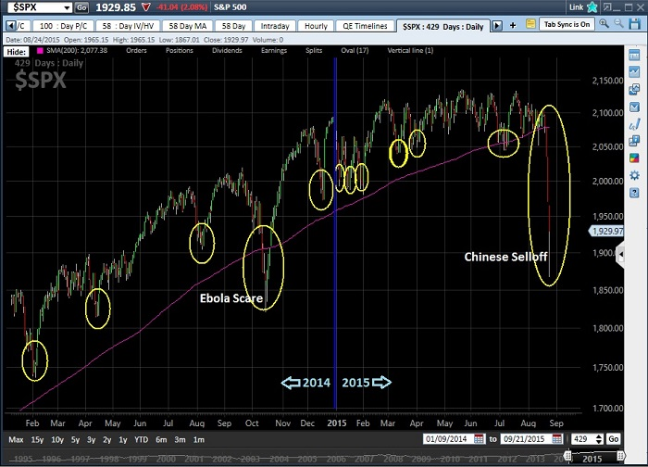
Source: StreetSmart Edge® as of August 24, 2015. Past performance is no guarantee of future results.
When volatility flares up, it’s important that you don’t let it derail your trading activity or your long-term investing goals. Here are seven ways to help keep you on track.

1. Stay disciplined and stick to your trading plan
Emotions have no place in trading. Decisions regarding which stocks to own should be based on fundamental analysis or other research that examines the financial condition of the underlying companies. When markets get choppy, knowing what to own becomes even more important. Once you have a target list of stocks, employing technical analysis—the study of stock prices and trends—can help you select your entry and exit prices.
Then, monitor your positions carefully. Set realistic profit and loss thresholds and follow them when the stock price moves outside of these bounds. Don’t expect to outperform the broader market each year; even professionals rarely do that.
Also remember that you don’t have to trade your entire portfolio actively—in fact, you shouldn’t. Instead, consider your personal risk tolerance when deciding how much of your portfolio will be used for trading—perhaps something like 20–30%—and then keep the rest of your portfolio as core holdings. With these longer-term investments, be sure to stay diversified and stick to your target asset allocation.

2. Maintain your risk tolerance and trade smaller positions
Most traders think they have a high tolerance for risk—that is, until they encounter a bear market. Before that happens, make sure you understand your capacity to withstand losses. Don’t assume overly large positions to maximize gains if you aren’t comfortable with the risks involved.
When trading, consider scaling in and out of positions by buying the stock in increments as its price fluctuates, or selling in increments when you think it may be getting close to a top. When properly managed, scaling in and out can reduce your overall cost basis and prevent you from owning too much of a position that is moving against you.

3. Use limit orders
Market orders can be appropriate for trading highly liquid securities during market hours because they let you buy or sell a stock at the best possible price available when the order is received. But market orders leave you vulnerable to market conditions, particularly if you enter them while the market is closed. Plus, you may not obtain your desired price.
Limit orders are more prudent in volatile markets. They allow you to specify the maximum price you’re willing to pay when buying a stock. Conversely, they let you set the minimum price you’re willing to accept when selling a stock. Be aware that while a limit order allows you to specify a price, there is no guarantee of an execution, even if the market moves and reaches your limit price.

4. Use proper risk management techniques
To help protect unrealized gains or limit your potential losses during market hours, consider using stop, stop/limit, trailing stop and bracket orders. When you place any of these orders, you have to decide how many points or what percentage below the stock price to place the order. Many traders have a standard policy based on their personal risk tolerance—such as 5% or 10%. For traders who determine the size of each trade based on the dollar amount invested, rather than the share quantity, a point value (for example, $1.00 or $1.50) may be more effective than a percentage.
Regardless of which methodology you use, be careful not to place the stop price too close to the current price, or daily price fluctuations might trigger an execution. Keep in mind, too, that all stop and protective order types have limitations. For instance, once an order is activated, it becomes a market order (which could fill at an unfavorable price) or a limit order (which may not fill at all). In a rapidly falling market, or a market that gaps in price overnight, there is no guarantee that the order will execute, or that the execution price will be the same as the stop price.

5. Trade the trend
Trying to pick the top and/or bottom of the market seldom works to your advantage—it’s usually much easier to follow the direction and momentum of the market than to fight it. If you’re going in one direction while everyone else is going in the other direction, you’ll likely get trampled.
In technical analysis, an uptrend is defined as a series of higher highs and higher lows. Similarly, a downtrend is a series of lower highs and lower lows. The number of occurrences it takes to establish a pattern will vary depending upon your time horizon. Long-term traders may look for trends in weekly or monthly charts, while shorter-term traders may use daily charts.

6. Take some profits off the table
If you own positions that have increased substantially in value, selling some of your shares is a good way to protect some of your gains. Plus, you still have the potential for further upside on your remaining position. During times of higher-than-average volatility, a slightly higher cash allocation is often prudent. By taking partial profits on some of your appreciated positions and leaving those proceeds in cash, you can help protect those profits and lower your overall risk.

7. When in doubt, wait it out
Just as markets can’t go up forever, they also can’t go down forever. Periods of heightened volatility come and go, and, more often than not, are short-lived. If you don’t have a good feeling for where the markets might be heading, sometimes just sitting it out isn’t such a bad idea.

Conclusion
Recent market moves—both up and down—can be unsettling for traders. On the one hand, you know there are opportunities out there. On the other hand, the markets can be punishing if your strategy proves wrong or ill timed. But if you use these seven steps, you can be in a good position to keep your trading on track.
Disclosures:
The information provided here is for general informational purposes only and should not be considered an individualized 4recommendation or personalized investment advice. The investment strategies mentioned here may not be suitable for everyone. Each investor needs to review an investment strategy for his or her own particular situation before making any investment decision.
All expressions of opinion are subject to change without notice in reaction to shifting market conditions. Data contained herein from third party providers is obtained from what are considered reliable sources. However, its accuracy, completeness or reliability cannot be guaranteed.
Schwab does not recommend the use of technical analysis as a sole means of investment research.
Periodic or otherwise staggered investment purchases do not ensure a profit and do not protect against loss in declining markets.
The S&P 500 Index is a market-capitalization-weighted index comprising 500 widely traded stocks chosen for market size, liquidity and industry group representation. Indexes are unmanaged, do not incur management fees, costs and expenses, and cannot be invested in directly.
The Schwab Center for Financial Research is a division of Charles Schwab & Co., Inc.
(0815-5526)
Additional Assets

Tweet (140 character limit)
Concerned about volatility in the market? Discover 7 ways you can adapt:

Merchandising Tool
Body Copy (70 character limit): Schwab has tools to help take emotions out of your trading.
CTA (25 character limit): Learn more (http://www.schwab.com/public/schwab/active_trader/trading_tools/trading_software/risk_management)

