Project | Trading Insights: Strategies for Dealing with Rising Interest Rates
Client | Adrianne Muscanere
Date | November 4, 2015

Existing Article

N/A

Keywords
Interest rates, Federal Reserve, yield curve

Trading Insights Homepage Assets

Thumbnail Copy (right rail/homepage tab/carousel –bottom of article)
Headline (50 character limit): Are You Ready For Higher Interest Rates?
Copy (60 character limit): Learn 6 strategies that can help

Homepage Hero/Carousel Copy (60 character limit)
6 Strategies for Dealing with Rising Interest Rates
Main Article Assets

Hero Image
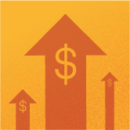

Hero Image (Thumbnail)
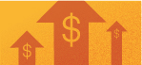

Hero Image Title
Rising Interest Rates

Byline
Schwab Trading Services Learning Center

Headline (50 character limit)
6 Strategies for Dealing with Rising Interest Rates
Summary (160 character limit)
Learn about what affects interest rates along with strategies that may help you reduce risk now that they rise.

Full article
From a peak in the early 1980’s into the past several years, both short-term and long-term interest rates have fallen precipitously. In fact, short-term rates fell to a level well below 1%. But just as how financial markets fluctuate over time, so, too, do interest rates. So it shouldn’t be much of a surprise that, once again, interest rates are on the rise.

Why Interest Rates Move
Interest is the amount paid by a borrower to a lender—above and beyond the repayment of principal amount of a loan or bond—to compensate the lender for lending the money to the borrower in the first place. In essence, interest is “the cost of money.”

Of course, individual securities (such as bonds) may carry varying interest rates due to factors that are more specific to those particular securities, such as the credit-worthiness of that particular issuer. But, in this article, we’ll be viewing interest rates through a broader scope.

Inflation is one factor that can influence the trend of interest rates. A sharply rising (or declining) rate of inflation is typically accompanied by rising (or declining) interest rates. In addition, if liquidity in the financial system is plentiful, interest rates tend to decline and/or stay low. When liquidity in the financial system is reduced, interest rates tend to rise and/or stay high.

In many countries, this liquidity is strongly influenced by the actions of the Central Bank. In the U.S., this body is the Federal Reserve, or as it is commonly referred to, the Fed. The Fed can increase or decrease the amount of liquidity in the U.S. financial system by raising or lowering the federal funds rate. The federal funds rate is the interest rate at which institutions lend money to one another on extremely short-term loans. One way the Fed can influence the level of the fed funds rate is via “open market transactions.” This involves the Fed buying or selling large amounts of previously issued U.S. debt securities, which then increases or decreases liquidity in the financial system.

Since the financial crisis in 2008, the Fed has, overall, been very “accommodating”—i.e., they have consistently provided a great deal of liquidity to the financial marketplace, which in turn has helped to cause interest rates to fall significantly and to stay low. However, given the cyclical nature of financial markets, these low interest rates are now starting to rise.

The “yield curve” measures the level of interest rates across the maturity spectrum. Typically—though not always—short-term interest rates will be lower than intermediate-term interest rates and intermediate-term interest rates will be lower than longer-term interest rates. This situation is referred to as a “normal” yield curve. With a normal yield curve, bond buyers essentially demand a higher rate of interest in order to lend money for 30 years than they will to loan money for 30 days since they will be locking up their money for a longer period of time.
It is important to note however, that at times, abnormal economic factors can cause the yield curve to “invert”—i.e., short-term rates rise above longer-term rates, or to be “flat” across the maturity spectrum.

When the Fed decides to change course by nudging the fed funds rate higher, it is possible that interest rates in general will rise, and/or that the yield curve may flatten out.

What Happens When Interest Rates Rise
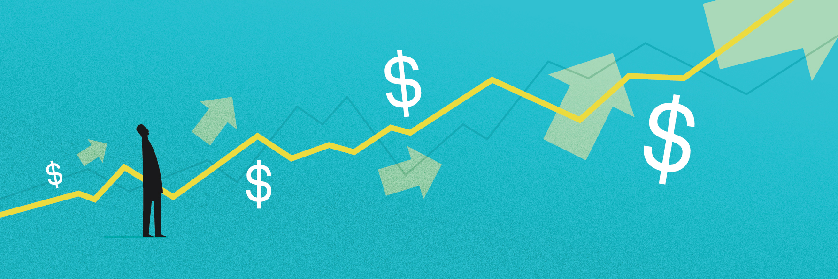
In a nutshell, when rates rise, the cost of borrowing goes up. Those who wish to borrow money—people, corporations, governmental bodies—have to pay more in interest in order to do so. This is not all good or all bad.

The good news is that new bond buyers will earn a higher rate of interest. The bad news is that as rates rise, existing lenders typically see the value of their initial investment decline as existing bond prices decline in order to make these previously issued (and lower yielding) bonds more attractive to buyers given the higher rate of interest now available via a newly issued bond in the marketplace.

Historically, rising interest rates have often—though not always—been a negative influence on stock prices. This is primarily due to the increased cost of capital that companies must bear when rates rise and the potential negative effect on corporate earnings. So while rising interest rates are a risk for bondholders, they can also increase risks for stock investors.

When to Hedge Against Rising Interest Rates
Timing when a rise in rates might begin is often a hot topic of conversation. It should also be noted that short-term, intermediate-term and long-term interest rates may not rise or fall at the same pace as one another. In any event, identifying in advance when interest rates will reverse their multi-year downtrend and start to rise in a meaningful way is difficult at best. The questions that many investors ask are “When will rates begin to rise?” and “How much higher will they go?”

A different, perhaps more useful way to consider interest rates is to ask, “What can I do to protect my portfolio and possibly even profit when rates do rise?” Fortunately, there are many choices available to investors. The key is in understanding the relative pros and cons of each alternative. So let’s take a look at six different tools an investor might consider.

Ways to Hedge Against Rising Interest Rates
For an investor concerned about the potential implications of higher interest rates on their present portfolio it may be useful to first consider their own objectives.

Do you want to:
*Reduce the impact that rising rates may have on your portfolio?
*Eliminate the impact that rising rates may have on your portfolio?
*Profit from a rise in interest rates?

Depending upon one’s individual objectives, an investor may choose one or more of the following alternatives.

Alternative #1: Sell some bonds holdings and raise cash
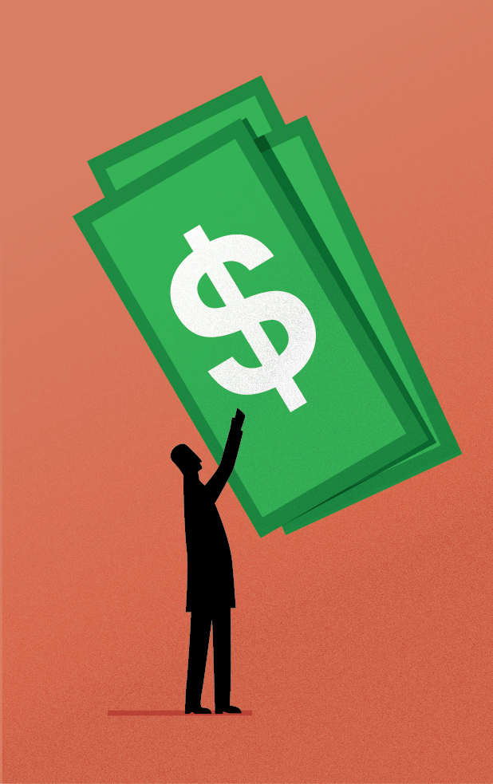
The simplest—and most drastic—action that an investor can take is to sell some of their current bond holdings and leave the proceeds in an interest bearing cash account or money-market fund which might benefit from a rise in interest rates.
Pros: Can significantly reduce risk if interest rates rise significantly. As rates rise, the rate of interest earned on cash and/or money-market instruments increases.
Cons: Primarily a defensive move. Little upside potential as money-market and other short-term rates are presently very low. If Fed holds interest rates low returns can remain very low compared to earning higher yields elsewhere.

Alternative #2: Move to Short-Term Bonds
Another potential defensive play is short-term bonds. Short-term bonds almost invariably pay a slightly higher rate of interest than a cash or money-market account. Short-term bonds typically do not fluctuate widely in price but the fact remains that unlike a savings account, a short-term bond can decline in value.
Pros: Typically offer a higher yield than rates available for saving accounts or money-market instruments. As rates rise, the interest paid increases over time
Cons: Short-term rates are presently very low and even short-term bonds can decline in value if rates rise.

Alternative #3: A Bond Ladder
A bond ladder involves buying a series of individual securities (typically treasury bonds, municipal bonds, investment grade corporate bonds or even CD’s) across a variety of maturity dates. As each bond matures, the investor “rolls” the proceeds into a new bond at the far end of the maturity ladder time frame. In a rising rate environment, this allows an investor to reinvest a portion of his or her portfolio at higher rates.
Pros: Does not require any market timing on the part of the investor. Allows an investor in a rising rate environment to systematically reinvest at higher rates.
Cons: Requires a relatively large investment to effectively diversify a portfolio of individual bonds. Also, commissions and bid/ask spreads can negatively impact returns. Also, does not eliminate interest rate risk, and reinvestment rates may be lower.

Alternative #4: Interest Rate Hedged Funds and ETFs
Interest rate hedged funds and ETFs typically hold a portfolio of a certain type of bond (treasury, investment grade corporate, high yield corporate) and then sell short treasury bond and/or treasury note futures in order to offset the risk of potentially lower bond prices. The basic idea is that the fund or ETF will offer an attractive dividend yield while offsetting at least some downside risk if interest rates rise.

Investors need to do some research before investing in interest rate hedged securities. As most of these securities are relatively new, there is no track record available to gauge how they might perform in a rising interest rate environment. Other considerations include the dividend yield, the average maturity of the bonds held in the portfolio (longer-term bonds will yield more but will also experience more price volatility than shorter-term bonds), and adequate trading volume and liquidity. Also funds and ETFs that hold corporate bonds and hedge by selling treasury bond futures may lose value if the spread between corporate bond yields and treasury bond yields widens. In this case the corporate bond portfolio may rise less (or decline more) in value than the hedge offered by the short treasury position.

Pros: Can allow an investor to continue to earn higher yields while potentially offsetting some or all risk associated with higher interest rates.
Cons: Limited track record, so hard to gauge effectiveness of hedging feature. Also, many interest rate hedged funds are not heavily traded.

Alternative #5: Variable Rate Instruments
As the name implies, a “variable rate instrument” is a security that does not offer a fixed rate of return or interest. The rate of interest that it will pay can vary over time. In a declining interest rate environment, this can be a negative for obvious reasons. However, in a stable environment and especially in a rising rate environment these instruments can offer investors a built-in hedge against rising interest rates. There are two primary types of variable rate instruments, so let’s look at them individually.

An investor considering variable rate securities needs to first determine if their priority is higher yield, greater price stability, or a mix of the two.

Variable Rate Category #1: Investment Grade Floating Rate Securities
These instruments are issued by investment grade companies with credit rating of BBB- or higher. Rather than paying a fixed rate of interest, floating-rate securities offer interest payments which reset periodically, with rates tied to a representative interest rate index. The rate of interest paid on these bonds can rise above or below the initial rate of interest stated when the security was issued. As a result, if interest rates rise, investment grade floating rate securities will see the level of interest that they pay rise as soon as the next rate reset date.

Pros: The ability to generate higher income as rates rise and the fact that they should not fall in price if interest rates rise, much unlike many other types of bonds.
Cons: The primary negative associated with investment grade floaters is that when issued they generally offer current yields that are significantly lower than a typical fixed rate bond of the same maturity offered by the same issuer. In addition, long-term price appreciation prospects are unknown and may be limited.

Variable Rate Category #2: Bank Loan Securities
A bank loan is the most common form of loan capital for a business. Bank loan funds or ETFs hold a portfolio of bank loans. The rate of interest offered by a bank loan fund or ETF resets when short-term interest rates rise. Bank loans however, carry sub-investment grade ratings and have significantly more credit risk than investment grade corporate bond floating-rate securities. That rate is usually set every 30, 60 or 90 days. The primary attraction for investors is that lower rated borrowers pay a higher rate of interest than investment grade borrowers, so bank loan funds and ETFs typically offer a higher dividend yield. Many bank loans have a “coupon floor,” which is the lowest coupon rate they will pay regardless of where short-term interest rates are. Today, most coupon floors are above short-term benchmarks, meaning most bank loans won’t benefit until short-term rates rise above that floor.

Pros: Can increase in value despite a rise in rates and can generate higher income as rates rise.
Cons: Bank loans are not recession-proof and default risk is higher. Bank loan funds and ETF tend to be volatile.

Alternative #6: Buy Inverse ETF or Funds
All of the securities discussed up until now will primarily serve to reduce portfolio risk and/or to generate higher yields over time in a rising interest rate environment. This category of security is specifically designed to increase in value as interest rates rise and bond prices decline. This category is for traders who want to speculate on an increase in interest rates and for investors who specifically want to hedge the risk to their portfolio posed by a rise in interest rates.

Pros: Can generate profits as longer-term interest rates rise.
Cons: Inverse funds and ETFs tend to be volatile and a poorly timed entry can hurt overall portfolio returns. They are designed for experienced investors who understand of the risks

Summary
The bad news is that rising and/or high interest rates can create risk for traders and investors. The good news is that thanks to the variety of trading instruments now available, you do not have to just “sit there and take it” now that interest rates have started to rise. The keys to hedging against rising rates are to:

1) Assess how much a rise in rates may affect your current portfolio.
2) Decide whether you want to reduce interest rate risk, eliminate interest rate risk, or profit from rising rates.
3) Choose the instrument or instruments which best achieve your own hedging objectives.

Important Disclosures
Investors should consider carefully information contained in the prospectus, including investment objectives, risks, charges, and expenses. You can request a prospectus by calling Schwab at 800-435-4000. Please read the prospectus carefully before investing.
An investment in a money market fund is neither insured nor guaranteed by the FDIC or any other government agency. Yields will fluctuate, and, although the fund seeks to preserve the value of your investment at $1 per share, it is possible to lose money by investing in the fund. Compared to the total return, the seven-day yield more closely reflects the current earnings of the fund.
Investment returns will fluctuate and are subject to market volatility, so that an investor’s shares, when redeemed or sold, may be worth more or less than their original cost. Unlike mutual funds, shares of ETFs are not individually redeemable directly with the ETF. Shares are bought and sold at market price, which may be higher or lower than the net asset value (NAV).
Leveraged ETFs seek to provide a multiple of the investment returns of a given index or benchmark on a daily basis. Inverse ETFs seek to provide the opposite of the investment returns, also daily, of a given index or benchmark, either in whole or by multiples. Due to the effects of compounding, aggressive techniques, and possible correlation errors, leveraged and inverse ETFs may experience greater losses than one would ordinarily expect. Compounding can also cause a widening differential between the performances of an ETF and its underlying index or benchmark, so that returns over periods longer than one day can differ in amount and direction from the target return of the same period. Consequently, these ETFs may experience losses even in situations where the underlying index or benchmark has performed as hoped. Aggressive investment techniques such as futures, forward contracts, swap agreements, derivatives, options, can increase ETF volatility and decrease performance. Investors holding these ETFs should therefore monitor their positions as frequently as daily. Past performance is no guarantee of future results.
Investing involves risk, including loss of principal.
The information provided here is for general informational purposes only and should not be considered an individualized recommendation or personalized investment advice. The investment strategies mentioned here may not be suitable for everyone. Each investor needs to review an investment strategy for his or her own particular situation before making any investment decision.

Additional Assets

Tweet (140 character limit)
With a potential interest rate hike on the horizon, learn 6 strategies that may help you reduce risk if it happens:

Merchandising Tool
Body Copy (70 character limit): Schwab has tools to help take emotions out of your trading.
CTA (25 character limit): Learn more (http://www.schwab.com/public/schwab/active_trader/trading_tools/trading_software/risk_management)

