India's problems are its reliance on inconsistent data

Indian Finance Minister presented the union Budget in the Indian parliament this week. The Budget speech laid out details of Programs to help the poor and build infrastructure and promote manufacturing in India a la 'make in India'. His efforts are honest and credible and India will surely continue to grow as a country and economy. India's problem is not that it lacks the ability and willingness to move forward but it's the reliance on inconsistent data that makes for poor economic choices. Let's look at two basic variables that go into policy setting to highlight these inconsistencies

- GDP Growth - India's GDP is growing at 7.6% this year (sharp improvement from the 5-6% levels two years back). and is expected to probably accelerate further in the coming years. This forms the basis for forecast of national accounts, tax collections and other government forecasts. Any economy which is growing at such a rapid pace should be a happy place, but not India. What does the high frequency data tell us?
  - There appears to be a slowdown in each and every segment of the economy. Corporate profits are down, the aggregate profits of 4,117 companies as reported on moneycontrol.com for the quarter ended December 2015 are down 11% Y/Y, and sales are down 5.5% Y/Y. And the trend is worsening, the same numbers six months back were -5% and -3% for sales and profits. This is not a picture of an accelerating economy but sharply decelerating growth.

 | Dec-15 | Dec-14 | % Change
 | (Rs. Crore) | (Rs. Crore)
Sales | 1,329,638.80 | 1,407,409.82 | -5.53%
Other Income | 57,963.12 | 55,111.65 | 5.17%
Gross Profit | 353,777.48 | 355,791.26 | -0.57%
Depreciation | 44,364.43 | 42,179.56 | 5.18%
Interest | 220,178.31 | 210,117.49 | 4.79%
Tax | 28,051.22 | 34,748.80 | -19.27%
Net Profit | 61,183.52 | 68,745.41 | -11%

Aggregate of 4,117 companies, Source – Moneycontrol.com
  - The Non-performing loans at banks are at the highest level in years, for example the country's largest bank State Bank of India counts over 10% of its loans as bad loans. The picture of the bank's balance sheet is one of an economic crises not an economic boom. The last time we saw these high numbers were more than 15 years ago. Again, an accelerating GDP is generally accompanied by improving credit quality for the banking system, we are going in the reverse direction.
  - Another feature of the last reported GDP data for the quarter ended December 2015 was the sharp recovery in manufacturing sector growth to 9.5%, while the more frequent index of industrial production saw a decline in the same period.
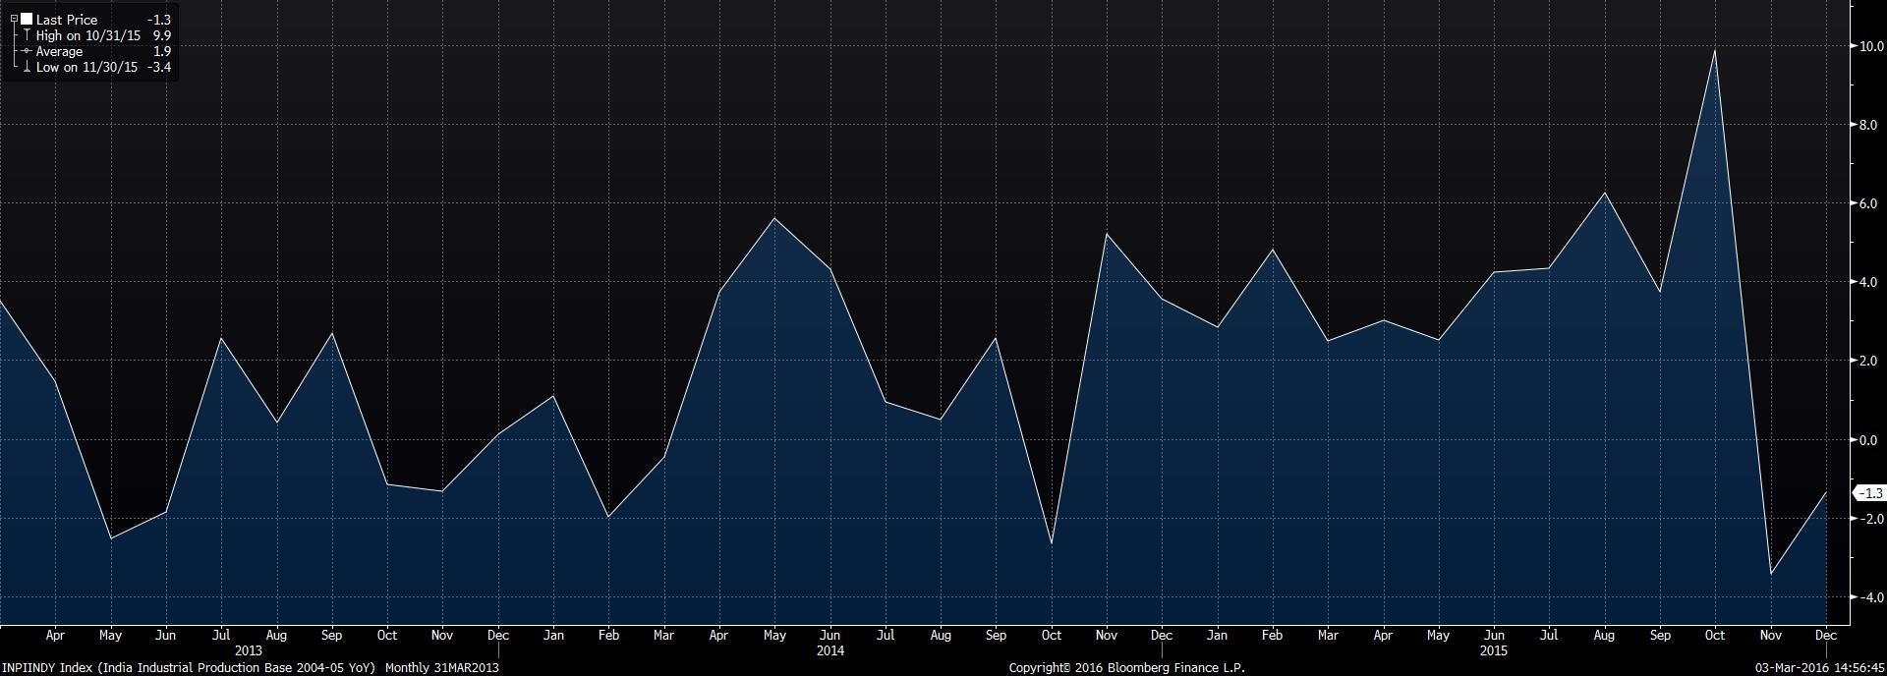

Chart 1 – 10 year India WPI inflation, Source - Bloomberg

  - If you pore through company earnings reports, all industries from banks to consumer staples to engineering goods to car makers to commodity producers to pizza sellers all are seeing a severe slow-down in growth.
  - So why is this discrepancy? India's GDP series was re stated last year and is not comparable with the previous series, some economists tell me that under the previous series we are probably at somewhere in the 4-5% range. In effect the current growth rates cannot be compared to the past and also do not tally with the high frequency data. Chinese forecasters have over the years developed alternate measures of growth using high frequency data, I am yet to see something like that in India.

The point is that policies and forecasts made using the GDP data are bound to be fraught with risks, for example direct taxes are forecast to grow at the rate of real GDP of 12-13% but profits are falling so we could end up with declining tax collection. The estimation of impact of fiscal stimulus on the economic growth may also be over-estimated.

- The other issue is with monetary policy and the interest rate policy.

Over the last 30 years monetary policy was set using the WPI (wholesale price index, which is PPI in most parts of the world) and not the consumer price index (CPI). Which was probably not the right policy, the RBI has moved to using the CPI for rate setting with an explicit goal of inflation of 5% for a healthy economy. India has had a chronic inflation problem and the RBI’s focus on targeting a lower long term inflation level is the right policy, but again the data underlying appears to be in consistent. The importance of lower rates cannot be stressed enough, consider the numbers
  - 25% of the fiscal budget expense is interest payments, imagine if rates were to be 4% instead of 8%.
  - The ‘Make in India’ phenomenon. If you want to be a globally competitive manufacturing hub, it cannot get there with borrowing cost at 12% for a company in India Vs a similar company elsewhere in the world borrowing at 2-3%! Your capital costs will be 30-40% higher (accounting for the interest during construction).

There appears to be less understanding of how we measure inflation and whether the underlying data is consistent. For example the WPI has now been negative for over 12 months. It’s the lowest in history, if we were to our old benchmark for rate setting, our real rates (Policy Rates – WPI) are at a all time high, for a industrial borrower who is seeing deflation in selling prices of its products, there is little reason to invest in new capacity.

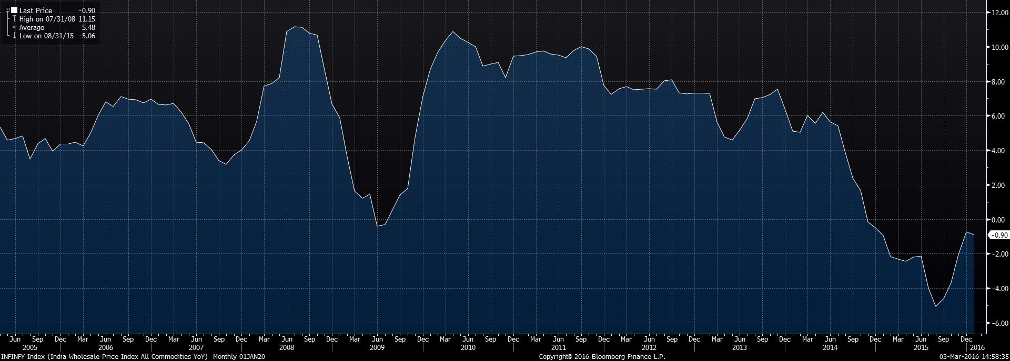

Chart 2 – 10 year India WPI inflation, Source - Bloomberg

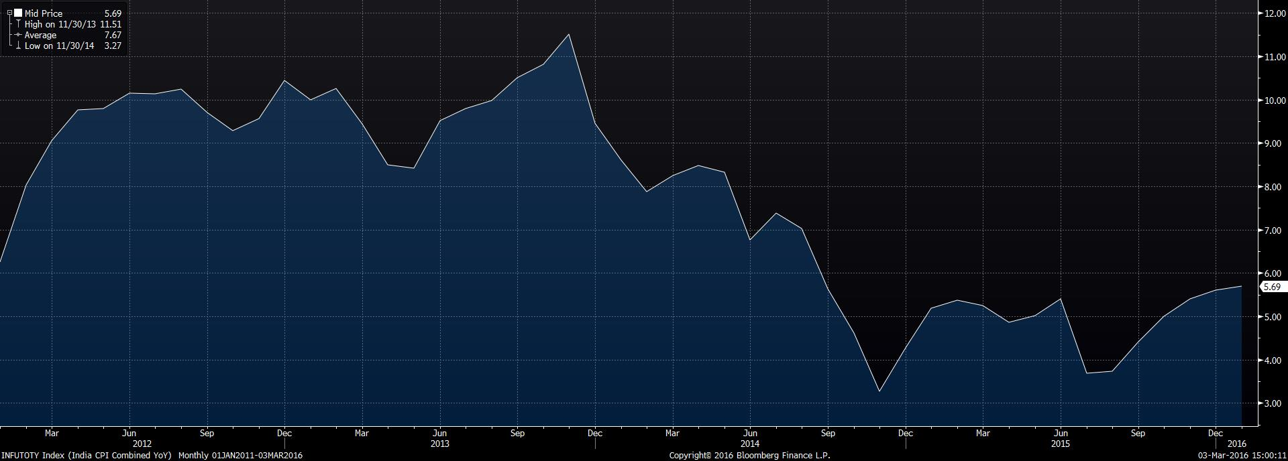

Chart 3 – 4 year India CPI inflation, Source - Bloomberg

There is a wide gap in the PPI and CPI in India, not consistent with what we see in any other large economy, clearly, they measure different things. If we look at the drivers of CPI, the break down is

 | Wt | Jul-15 | Aug-15 | Sep-15 | Oct-15 | Nov-15 | Dec-15 | Jan-16
Food and Beverages | 45.9 | 2.8 | 2.9 | 4.3 | 5.3 | 6.1 | 6.3 | 6.7
Pan, tobacco and intoxicants | 2.4 | 9.8 | 9.4 | 9.3 | 9.4 | 9.4 | 9.3 | 9
Clothing and Footwear | 6.5 | 5.9 | 5.9 | 5.9 | 5.6 | 5.8 | 5.7 | 5.7
Housing | 10.1 | 4.4 | 4.7 | 4.7 | 4.9 | 5 | 5.1 | 5.2
Fuel and Light | 6.8 | 5.4 | 5.8 | 5.3 | 5.3 | 5.3 | 5.4 | 5.3
Miscellaneous | 28.3 | 3.4 | 3.1 | 3.3 | 3.5 | 3.8 | 4 | 3.9
Core CPI (ex-food ex-fuel) | 47.3 | 4.3 | 4.1 | 4.3 | 4.4 | 4.6 | 4.7 | 4.7
Headline CPI | 100 | 3.69 | 3.74 | 4.41 | 5 | 5.41 | 5.61 | 5.69
Table 2 :- India CPI Inflation Source: CSO

What we see in Table 2 is that most components are supply side and not demand led measures of inflation. Food is the largest part, and a lot of this depends on Government procurement prices and monsoons etc. Fuel and light is clearly not linked to fuel prices which are down 50% this year and housing seems odd given that most cities are seeing declining prices and rentals from what we hear anecdotally.

Conclusion – Indian policy makers are doing the best they can based on the data that is made available to them. The problem lies with the inconsistencies in the underlying data, which is what increases risk of policy mistakes. If the policy makers were told that the GDP growth in fact is 4% and not 7.3% and that inflation is 2% and not 5% we would see very different outcomes on both monetary and fiscal policies.

