Costco Is A Hold Stock For Now
Summary
- Q1 2016 analyst estimate managed to bring the price of Costco’s shares by 5%.
- I see a declining trend in the growth of total membership fees. This is obviously a red flag.
- I think the company’s share price will continue falling in the short-term but will level off a few percentage points below.
A great business model, a huge corporation, a gigantic customer base – this all describes Costco Wholesale Corporation (NASDAQ: COST). Besides, the company has been growing year after year, while its market capitalization has also been on the rise. However, there are red flags, as well. The company positions itself as a leading wholesaler. The price of its shares has been going up for quite some time. The all-time high was reached on December 8, 2015, and amounted to $168.87 per share. However, the stock has retreated by almost 15% since then.
If we analyze the company’s financials and analyst estimates, we will see that:
“Costco’s adjusted earnings per share amounted to $1.09 in Q1 2016 versus a consensus EPS of $1.17. The EPS fell by на 2.7% year-over-year. Q2 2016 net sales equalled to $28.17B compared to $27.22B in Q1 2016”.
(Source: Seeking Alpha)
Costco tried to improve growth metrics by increasing net income and improving operating efficiency. It seems that everything is going well within the company: it has been growing quarter over quarter and has been continuously paying stable dividends. One may ask: “What else does the company need to keep prospering?” I think that the company is losing ground in some respects, and there are reasons for that. For example, when we look at sales growth, we will see that it is declining:
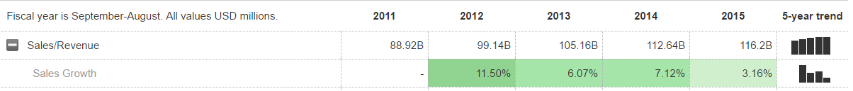
(Source: Market Watch)

Costco has shown a 2.6% year-over-year sales growth in Q2 2016. Here is why the company is losing ground: growth in membership fees has been in continuous decline since Q4 2014. You can see this below:
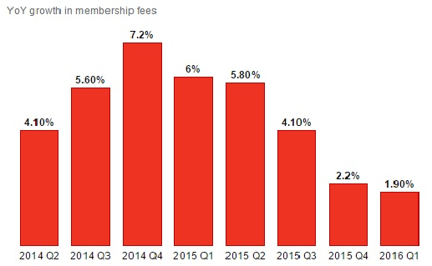
(Source: Amigobulls.com)
Declining growth rates in membership fees implies that Costco will have to spend more and more money on marketing. Until today, the company has not been active in marketing due to its brand power and recognition. Extra marketing expenses will reduce margins and, hence, the company’s growth in the mid-term.
Bulls may think that the growth in membership fees is hindered by currency swings. However, I think that the US dollar is not to blame. I think that the company has a strong brand name, and its customers are extremely loyal to it. Hence, even if prices in the stores increase, the customers will not go elsewhere (i.e. demand is inelastic). Besides, e-commerce revenues have grown by 30% year-over-year. This implies that customers have not noticed the strengthening of the US dollar.
There is also an opinion that Costco is overvalued. This is partially true. The company is somewhat overvalued relative to its peers and the market overall, and we may see further declines in its share price.
Costco trades at a premium to its peers: its P/E ratio is 26.6х compared to S&P 500’s ratio of 15.3х and S&P 500 Food & Staples Retail Index’s P/E of 17.3x. The company is also more expensive according to other financial metrics like the EBITDA multiple and the P/B ratio.
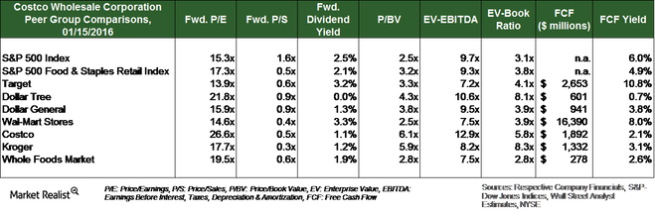
(Source: MarketRealist.com)
I personally think that Costco’s valuation will continue decreasing. If you are a conservative investor looking at buying Costco’s shares for the long-term, I recommend hedging your equity position in the company with collars.
Collars are for active investors looking for extra edge. A collar is an option strategy that involves buying puts and financing them with the sale of calls. With Costco, I specifically recommend June 2016 options. Currently, one can buy a $139 put almost at a zero cost by financing it with the sale of a $149 call:
Initial outlay: $12 (net debit)
Maximum risk: $537 at a price of $115 on day 17th May 2016
Maximum return: $468 at a price of $149 at expiry
Breakevens at expiry: $144.30
The risk-return profile of this trade can be seen below:
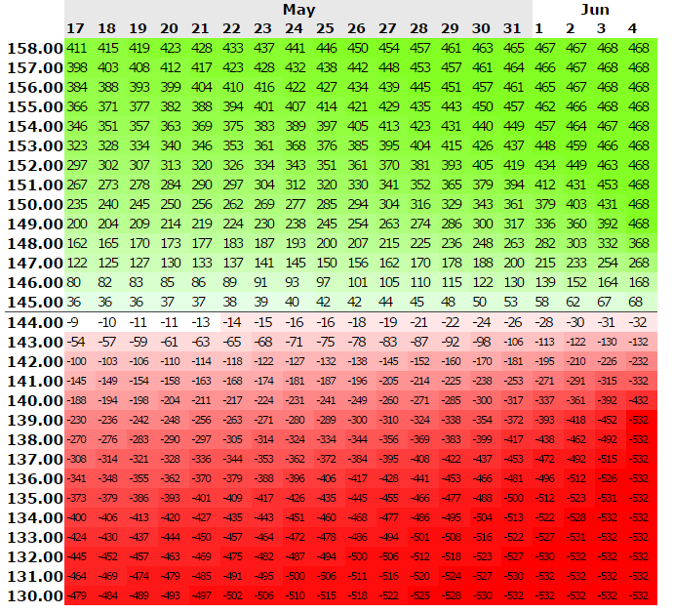
(Source: optionsprofitcalculator.com)
Finally, I wanted to mention dividends. If you are a long-term investor looking for income, Costco is a great choice. However, you have to remember that above-average dividend growth is in question due to aforementioned growth concerns. In addition, Costco actively finances its capital expenditures by own funds, so dividend growth is currently not a priority. If you need higher dividend yields, look at other blue chips. Costco’s peers may be a better choice for long-term dividend investors.
I rate Costco as a HOLD stock at this point in time.

