OPEC Production Monitoring, Historical OPEC Production Allocations and Game Theory Applied
Bulls and Bears invested in or thinking about capitalizing on investing in Crude Oil Futures & ETF’s (NYSE: USO, UWTI, DWTI), Oil Companies (NYSE: BP, CVX, XOM, COP), Midstream (KMI), Oilfield Service Companies (SLB) and trying to gain a grasp on the macroeconomic trends inherent in oil prices that underline these financial instruments may benefit from a bit of history and the academic framework known as Game Theory. Oil prices most recently have been lifted above $50 but have been testing $55 breakout levels in 2017. With the upcoming monitoring committee meeting in Vienna on the 21st & 22nd investors should look for key outcomes that will help solidify prices.
An infamous quote attributed to Spanish philosopher George Santayana articulates that those who cannot remember the past are condemned to repeat it. Throughout the year, I noticed a significant amount of tweets, articles and rhetoric floating around from oil analysts worldwide contending that the infamous cartel originating in 1960 was long gone. My view was similar to that held at the poker table. Regardless of their last bet you better maintain the consideration of that player as a credible threat when they hold approximately 40% of the chips as OPEC does with worldwide oil production. Justifiably given the cartels past, those same birds tweeting away about no chance of OPEC closing on a deal are now contending that OPEC nations will only exceed production allocation limits.
In review for this article I assessed each +/- 20% pricing event since 1970 (as most reliable statistical data dates back to) and through the theoretical assessment of the behavior of OPEC and by analyzing the current competitive market it was possible to outline the positioning that OPEC was in prior to the deal outlined at the 171st OPEC meeting this past November. This pricing pattern aligned historically with one similar from the past and had a very different outcome then what oil price bulls expect from the most recently announced deal. As a source of primary data, I aimed to collect direct information from data repositories widely published by annual reports from the International Energy Agency ((IEA)), U.S. Energy Information Administration ((EIA)), British Petroleum ((BP)) and OPEC themselves. The research most notably references one year-over-year variance and significant event in 1987, which resulted in OPEC production allocations that was very similar to today.
The Game Theory Model & Oil Prices
First and foremost is a brief explanation of the academic drug everyone has been dishing out high levels of to sound cool at parties since Hollywood threw Russell Crowe into A Beautiful Mind and most recently a Richard Thaler cameo into The Big Short.
In an oligopoly such as the case for the oil producing nations of the world, firms are affected not only by their production decisions but also by the production decisions taken by other firms in the market. Game theory is where each actor when deciding on a course of action or ‘signals’ expects the others will copy with a response given their obvious production capacity. There are two applicable concepts of Game Theory here, the Nash Equilibrium concept described as a set of strategies that restrict other players to do better by unilaterally changing strategies (as we saw with the coming together and formation of a production quota) and the Prisoner Dilemma concept which is a type of game that illustrates why cooperation is difficult to maintain in an oligopoly even when it is mutually beneficial due to each individual player attempting to maximize their own benefit (as we may see in the coming year whether nations under the agreement remain under their respective quotas given higher prices).
In this game the dominant strategy of each actor is to defect for self-interest and it is observed that all players always want to produce more in order to maximize profits. In turn, the best strategy for one oil-producing nation is to increase its own supply while trying to discourage other nations to produce high volumes, or in the present case, produce as much as industrially possible and try to get others to reduce. While all players are rational and want to maximize profits, increased production and excess supply will result in lower oil prices as outlined as the concept of a Prisoner Dilemma. The countries playing cooperative games have a difficult time trusting each other especially if with the level of uncertainity involved which is why as outlined later the monitoring committee guidelines, enforcement and any penalties to countries that over produce will be of the utmost importance.
Whether inadvertently or not much has been learned throughout the history of oil pricing shocks and Game Theory is very much present among all the key players globally to be competitive in the global market. The players in the oil market have previously attempted collaborations to balance pricing through production levels and netback pricing but with all these attempts throughout history, it is understood that signaling one another with different disruptions created by all have impacting outcomes for all players in the oil market. By inferring from observed behavior we can forecast the likely actions and reactions in the business world.
OPEC Production Quotas (1987)
A similar price shock had stifled markets from the period of 1980 until 1985 that resulted in an average inflation-adjusted negative 45% correction. This was further coupled with the 1986 single year price shock of negative 47% in 1986 and left OPEC in a similar situation it was in towards the end of 2015. With respect to price, it had dived from the 1980 high of approximately $115 USD/bbl to around $20 USD/bbl.
It was high time for action and at the end of 1986, 12 of 13 OPEC members with the exclusion of Iraq, agreed to establish quota arrangements at the 82nd OPEC Meeting. These levels were 15.648 MMbbl/d for the first half of 1987 and 16.441 MMbbl/d for the second half (OPEC, 2016). Furthermore, these quotas would be enforced through a production monitoring system through an external auditor and the market price aim be established which all should sound very familiar by now.

Actualized Production Levels
Figure 1 below depicts the production levels as reported by the ((IEA)) (2016), ((EIA)) (2016) and ((BP)) (2016) for the years 1986 and 1987. This includes all current OPEC countries with the exclusion of Iraq as dictated by the terms of the agreement & Angola who became a member country in 2007.
As shown below, the 1987 agreement called for approximately an average production cut from all three reporting agencies of 2.02 MMbbl (cut to reach the yearly quota average of 16.04 MMbbl). The average production from the same three agencies was reported in excess of 1.5 MMbbl of the quota levels instated by OPEC allocations. The cut in plain terms was not adhered to. You may also be wondering why the ((BP)) numbers are substantially lower, and that can mostly be accounted for lower production numbers from Kuwait and higher numbers from Iraq, which given the upcoming Gulf War and dispute over oil fields makes sense.
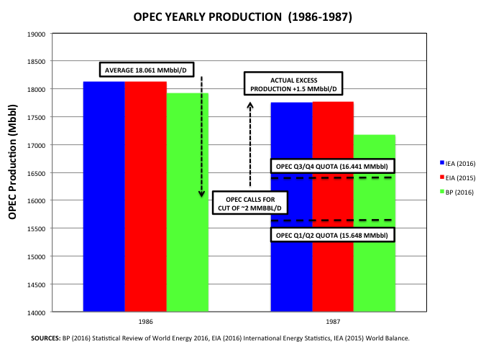
Figure 1: OPEC (exclusion of Iraq) Yearly Production from 1987 to 1989 (IEA 2016, EIA 2015, BP 2016)
Upon further analysis and as displayed by Figure 2 below, we can see the average yearly change from each producing nation of OPEC. By the numbers OPEC did achieve a cut of approximately 571,000 bbl/d from their average 1986 production but this is far short of the called upon reduction of approximately 2 MMbbl/d. While the terms of the deal are not stated, assuming a similar deal as the one cut in November, only the nations of Ecuador and Indonesia in fact were below their OPEC production allocations and given the circumstances Indonesia was nowhere near producing at its allocation levels in excess of 2 MMbbl/d, the deal was definitely not complied with.
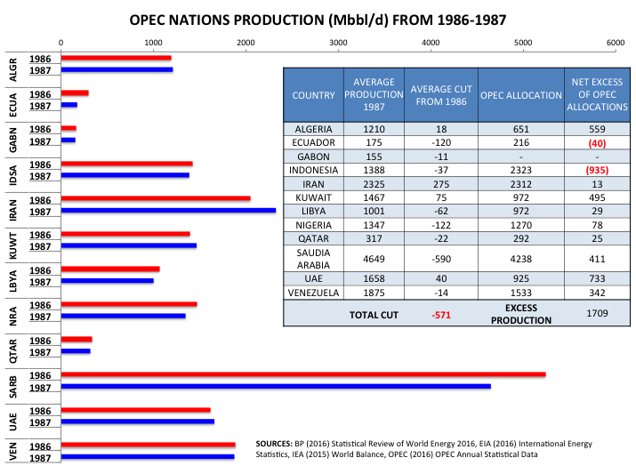
Figure 2: OPEC Yearly Production Change (Mbbl/d) from 1987 to 1989 (IEA 2016, EIA 2015, BP 2016, OPEC 2016)
Strictly by the numbers, this means that the nation of Ecuador was the only one that really complied with the cuts. Most notably the nations of Algeria, Iran, Kuwait and the UAE all also increased in production. Saudi Arabia fell short of its committed cut as the OPEC leader by almost 400,000 bpd although they did have the biggest reduction from 1986 production.
Key things to look for from OPEC Monitoring Meeting on January 21st/ 22nd
A key tool competent organizations and individuals employ to achieve goals and objectives attributed to George Doran in 1981 is the concept of SMART goal setting. The acronym stands for Specific, Measureable, Attainable, Realistic & Time Based. As you can imagine each of these is of vital importance to the OPEC meeting. Specifically and Measurably as outlined in Table 1 below, each country must adhere to the cuts allocated to them as clearly outlined in the November OPEC meeting. Whatever measurement or tracking method they choose should be clear, consistent and transparent for analysts to see. Being attainable is a concept that is also important as we have already developed in the 1987 cuts. When compared to the substantial cuts of 1987 we can see that proportionally speaking that the cuts are much more in line with higher production levels that are seen today. This should be much more attainable then the levels that were called upon in 1987 but given the drastic decrease in oil profitability in the 1980’s one can assume where those extreme measures came from. Most importantly as a part of Measurability and Attainability will be the punishments nations will face for failing to enforce their cuts. This also needs to be outlined and communicated in a clear, concise and transparent method.
COUNTRY | REFERENCE LEVEL | ADJUSTMENT | PRODUCTION LEVEL
ALGERIA | 1089 | -50 | 1039
ANGOLA | 1751 | -87 | 1664
ECUADOR | 548 | -26 | 522
GABON | 202 | -9 | 193
INDONESIA | - | - | -
IRAN | 3975 | 90 | 4065
IRAQ | 4561 | -210 | 4351
KUWAIT | 2838 | -131 | 2707
LIBYA | - | - | -
NIGERIA | - | - | -
QATAR | 648 | -30 | 618
SAUDIA ARABIA | 10544 | -486 | 10058
UNITED ARAB EMIRATES | 3013 | -139 | 2874
VENEZUELA | 2067 | -95 | 1972
SOURCE: OPEC (2016) Annual Statistical Data
Table 1: OPEC Yearly Production Change (Mbbl/d) from 1987 to 1989 (OPEC, 2016)
Realistically, OPEC has also done a good job of excluding Nigeria & Libya as well as offering Iran pre-sanction levels to account for the outliers of the group. The final term, Time-Based is also important as the monitoring committee should be setting up specific reportable dates to communicate results and structure further meetings in the future to continue to enforce cuts or allow the market to rebalance itself.
Conclusion & Investor Takeaway
So what effect did the events of 1986 and 1987 have on oil price? The average price increased from 1986 to 1987 by approximately 19% from $31.72 to $37.62. The following year in 1988 the price retraced all gains back another 19.5%, which may be contributed to lack of adherence to the quotas for the first and second half of 1987. As previously explained whereas the Nash Equilibrium qualified OPEC to create a deal, we may see as in 1988, the Prisoners Dilemma take a hold of nations production and suppress any gains seen by oil price.
The production cuts announced in November of 2016 have alone caused a significant and sustained swing. I do not believe it is because traders are more trusting, I believe it is they see the dominant strategy just as OPEC does for the benefit of all parties involved. As I mentioned in the introduction of it being irrational to discount a 40% market share holder, it is equally as irrational to believe that OPEC and each of these individual nations do not have game theorists and seasoned strategists that are not well aware of the Nash Equilibrium & the Prisoners Dilemma in addition to the effects of past actions. That with the fact that these levels are much more obtainable to the producing nations will sway things more in line with reaching and complying with an agreement for the betterment of all OPEC nations. It is important to look for all aspects of the SMART framework from the upcoming monitoring committee meeting and following up closely with their production measurability techniques. Remember any signaling or indication from a sway from the Nash Equilibrium could cause significant straying from the collective agreement.
What is funny is that the price really did not get a boost until the geopolitical uncertainty of the Gulf War in 1990. Given some of the signaling of reinstated sanctions on Iran, the Venezuelan economy, geopolitical uncertainty in Nigeria, Russia etc. there a few historical events that correspond to what the next big event causing a positive price shock. What the future holds will be interesting, but what we can observe in the past is market behavior as a result of observable previous actions.
Seasoned and highly experienced traders always boast that their experience allows them to just react in time to market conditions and by learning from the past we can gain a little bit of insight into their experience. One thing is for certain, any lack of compliance to the agreed upon cuts will have a strong negative impact on oil prices as well as the decision making process for each nation involved within the Nash Equilibrium.

