Phillips 66: Another Buying Opportunity Or Sign Of A Major Fall?
After Nine Straight Weekly Declines, Is Phillips 66 A Buy?
Phillips 66 (NYSE: PSX) recorded nine consecutive weekly declines with its Friday’s close at $78.03, pushing the investors to think if they should consider making a fresh round of investments now. In this article, I will discuss why the stock is a good buy right now and also present a case where the stock could fall more than many expect it to.
I want to say it at the outset that this is a technical analysis article. But, even if you are not well-versed with the study of price behavior and technical patterns, you needn’t worry since I will present the information in an easy-to-understand manner. If doubts still remain, do not hesitate to use the comments section below for any queries.
After recording such a big losing streak, it is natural to expect that the stock must have tested oversold territories. So, I looked at the weekly PSX price chart (submitted below) and employed two technical indicators – Relative Strength Index and Money Flow Index – to find out their latest values. The 14-week RSI value stands at 37.3069 while the 14-week MFI value stands at 21.6224. It must be noted that a value of 30 or lower represents oversold conditions in RSI while a value of 20 or lower serves the same purpose in MFI. So, the stock is indeed closer to its oversold readings.
Having said this, I want to clarify a common misconception. Many a time, when a stock goes oversold, investors rush to buy it, failing to believe (or understand) that the reading can go sharply lower than 30 (in RSI) and bring in potentially huge losses. The stock can also remain drastically oversold since the above indicators are directional in nature. The better way to utilizing the oversold readings is by cutting down on short positions (if any) since it enhances the probability of a technical rebound but it is not written in stone.
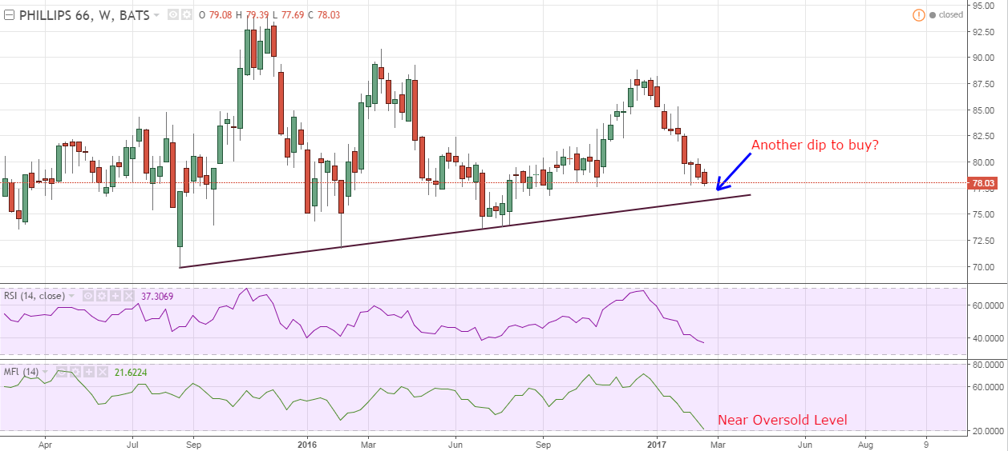
Source: TradingView
The weekly price chart presented above also illustrates that the stock has nearly dropped to the strong upward-sloping support trendline that has survived the stock since August 2015. If this trendline were to hold once again, the stock should not fall below $76.
Some perspective on this price action. Firstly, it clearly tells us that the market is confident at buying the stock at higher lows (dips) as the time progresses. Secondly, the lower tops suggest that the momentum quickly runs out as the stock attempts to scale new highs. This has resulted in a contracted range for the stock, suggestive of the near-term indecision in the market.
There is good news for the dividend income investors as well. The current dividend yield of 3.24 percent is at the higher end of the multi-year range (mid-2012 to present). In fact, only 15.3 percent of the time has the stock been available at a yield higher than 3%. Locking in a historically high dividend yield in a good company is never a bad decision. Dividend income investors may be right around the corner to purchase this Warren Buffett-owned stock.
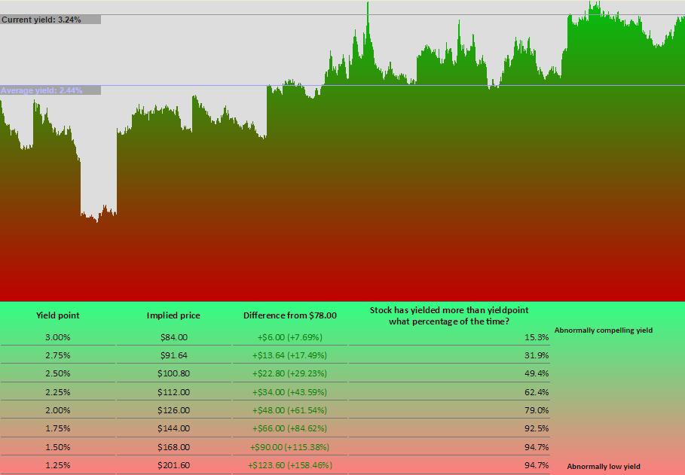
Source: YieldChart.com
There is another strong support coming in for Phillips 66 near $75. Visiting the weekly PSX line chart suggests that a two-year horizontal support trendline will cushion the stock if the decline extends in the coming sessions as well. The longer the timeframe of the trendline, the harder it is to pierce.
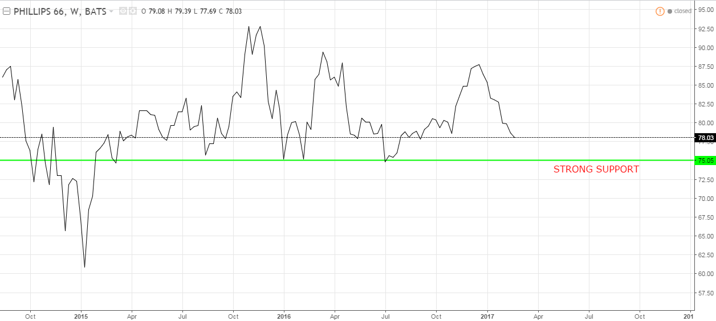
Source: TradingView
In totality, the stock can easily rebound from the current level or after a 3-4 percent correction, taking support from the couple of support trendlines, historically high dividend yield, and near oversold conditions.
But, in a case when the market performs unexpectedly and the stock is unable to attract buyers at $75 or so, what levels could be reasonably expected? An investor must always be prepared for any negative surprises in this overly inflated stock market.
PSX decisively pierced the 200-day simple moving average – a widely respected technical indicator – in early February. It attempted to climb back above the 200-day SMA but failed and is extending its drop now. Take a look below.
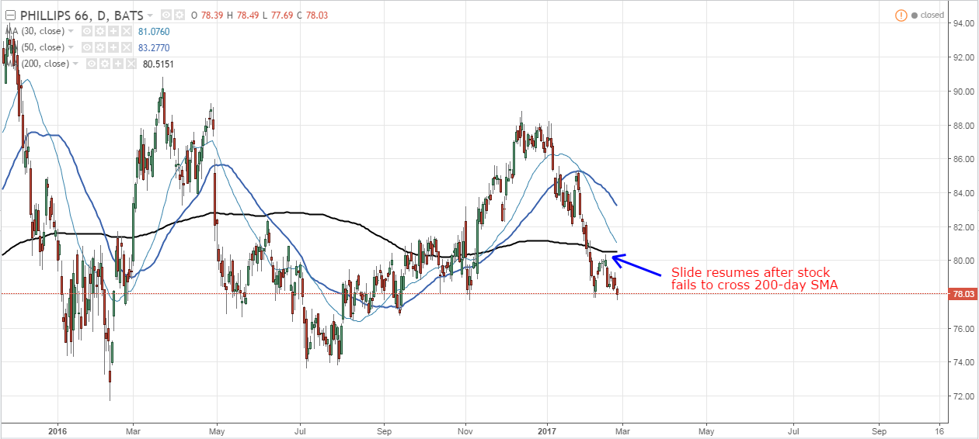
Source: TradingView
If the stock is unable to bear the selling pressure near the 200-day SMA, it increases the chances of a breakdown, bringing in more losses for the investor.
Now, a breakdown might seem hard to digest but it is entirely possible. Many Exxon Mobil (NYSE: XOM) investors also did not want to believe at first that the giant could pierce the important support levels but to their utter shock and disbelief, it did. And now, there is a good chance that the stock could slide to $72-$74.
I have presented the XOM weekly price chart below, marking similar trendlines as in PSX and the same technical indicators, RSI and MFI, to prove a point that an investor should be prepared for everything. When XOM was trading north of $85, many plainly rejected the idea that the weekly supports could be violated.

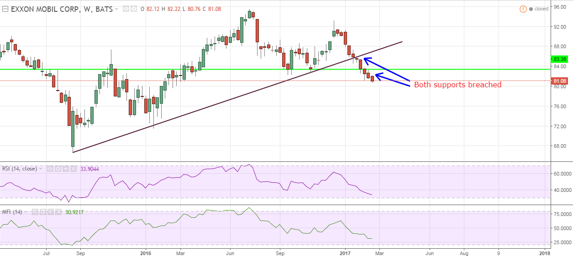
Source: TradingView
Conclusion
The point to draw from this technical analysis of Phillips 66 is that the stock is an attractive buy now but there is no need to put all the eggs in one basket. To prove that the bulls’ safe-haven near $75 can be breached, I have provided the latest Exxon Mobil case wherein a couple of important long-term supports have recently been breached.
An investor would do well to create a small long position in PSX now but also keep in mind the probability of sub-$75 levels. He must definitely consider his risk-appetite before committing his investment dollars.
Note: I cover several stocks in different sectors as well as S&P 500, crude oil, gold and silver, U.S. dollar, etc. So, if you liked this update, and would like to read more of such informative articles, please consider hitting the "Follow" button above. Thank you for reading!

