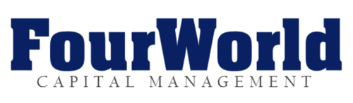

**Contact:** Allan Ripp 212-262-7477 [aripp@rippmedia.com](mailto:aripp@rippmedia.com)

**FourWorld Capital Urges Investors in Flotek Industries to Raise Key Questions During Company’s February 9 Earnings Call**

***Oil service company has failed to present data supporting benefit of its fracking additive CnF or defending shrinking customer base in face of critical research issued by FourWorld; Flotek must answer to investors in earnings call on Thursday, February 9, 2017 at 8:30 a.m. EST.***

***---------------------------------------------------------------------------------------------------------------------***

NEW YORK (February 8, 2017) **–** Oilfieldservices company **Flotek Industries** (NYSE: FTK) is slated to host an earnings call this Thursday, February 9 – participating investors and analysts may want to come armed with a few questions, courtesy of **FourWorld Capital Management.**

As of the publication date of this news release, FourWorld, and FourWorld managed accounts, have a direct or indirect short position in Flotek stock, and stand to realize significant gains in the event the price of Flotek stock declines.

FourWorld released a research report this past December 7, demonstrating that Flotek overstated the impact of its fracking additive CnF on well productivity. The report, entitled [***Drilling Down to Zero***](http://www.fourworldcapital.com/research/), analyzed performance at more than 600 wells in Colorado’s DJ Basin and concluded that CnF produced zero benefit in extracting oil and gas from shale wells.

FourWorld’s report presented evidence that the majority of major oil and gas producers have discontinued use of CnF products in their own well completions in the last several years. The report questioned the long-term viability of Flotek in view of the company’s heavy reliance on this single commodity product derived from oranges.

On December 20, Flotek released an interim update on fourth quarter operations, but did not directly address critical questions raised by FourWorld’s report. The following day, the company issued an 8-K that included a letter from MHA Petroleum Consultants, the firm hired to do an efficacy study on CnF, which also failed to address the questions raised by FourWorld’s report, but did reveal that Flotek admitted to at least one significant data error.

In light of the company’s refusal to address critical issues raised in its report, FourWorld issued an open letter to Flotek CEO, John Chisholm on December 27, urging the company to address a list of concerns raised by the December 7 report and release additional information regarding CnF and other matters, so investors can verify results published by the company. Forty days have passed without a response from Flotek.

These actions – and inactions – by Flotek should prompt investors to demand answers to open questions on the Feb. 9 earnings call. Here are some starting points:

1. **Why did MHA Petroleum Consultants suddenly change their preferred performance measurement metric from using 12-months of ACTUAL oil production to the SUBJECTIVE metric of Estimated Ultimate Recovery in the 8-K you filed on December 22, 2016?**

FourWorld reiterates its December 27 request to release a list of well identifiers (API numbers) used by MHA in its different reports that purport to address the efficacy of CnF, so that investors can verify the results.

1. **Even using estimated recovery metrics, MHA's letter states the impact from CnF fell from 58.4% to 10.4% in Area 1 after adjusting for a trade name Flotek failed to provide and geography. That is a staggering drop of 48 percentage points by re-classifying just 36 wells from CnF to non-CnF and looking at wells closer together (but still ignoring other key factors). Do you agree? Can you explain why this stunning change in results doesn’t prompt a new study that looks to control for more obvious, key variables (like well length, geography, operator and water volume) and corrected data?**

FourWorld reiterates its December 27 request to release a complete list of trade names for frack fluid additives that contain its CnF technology, so that independent third parties – operators as well as investors – can evaluate the performance of the product.

1. **According to FracFocus data, OilPerm FMM-1 has been used in 26% of all horizontal well completions since 2014. Does OilPerm FMM-1 contain Flotek chemicals, including D-Limonene, and is it covered by your CnF patents? Has Flotek EVER produced a list of CnF trade names that contained the OilPerm FMM-1 trade name? Do the chemicals used in OilPerm FMM-1 show up in “FTK CnF Sales” volume and revenue figures published in the third and fourth quarter investor presentations and earnings calls?**

FourWorld reiterates its December 27 request to inform the investment community whether Flotek has ever issued a document indicating that Oil Perm FMM-1 is a CnF product, and whether CnF sales figures issued by Flotek treat Oil Perm FMM-1 as a Flotek product.



1. **According to FracFocus data, only six operators report putting CnF in a horizontal well in the United States during the month of October 2016. According to your records, how many operators do you see using a CnF product in a horizontal well during October?**

FourWorld reiterates its December 27 request to acknowledge or refute the attached graph, which describes a rapidly shrinking customer base, despite statements to the contrary made in your Q3 earnings call.

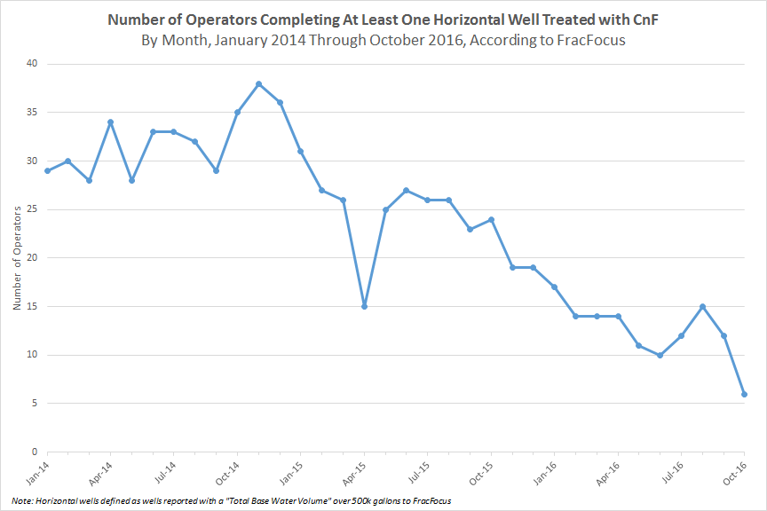

We encourage investors to read the full report, *Flotek: Drilling Down to Zero*, available on our website at[www.fourworldcapital.com](http://www.fourworldcapital.com)**.**