Exxon Mobil: Boosting optimism following Analyst day.

Exxon Mobil (XOM) held a meeting or analysts and management is boosting optimism for the investment cases. XOM reiterated the value of its competive position across the value chain from the Upstream business to its downstream operations and Chemicals. Across all three aspects management presented opportunities to stay ahead in each segment given its ability to invest in research and technology and continually invest in optimizing operations and capturing synergies. Here XOM touted its work in reducing the workforce by 27% and a $13 Billion, or 23%, cost reduction since 2011.

XOM Competitive Position

XOM management touted its formidable competitive position relative to the other oil majors. First, XOM has an incredibly strong balance sheet both in terms of size but use of leverage. Looking at the below XOM has the lowest leverage ratio with highest capitalization among its pier group. This has led XOM to have the highest credit rating of oil majors from Moody’s and S&P.

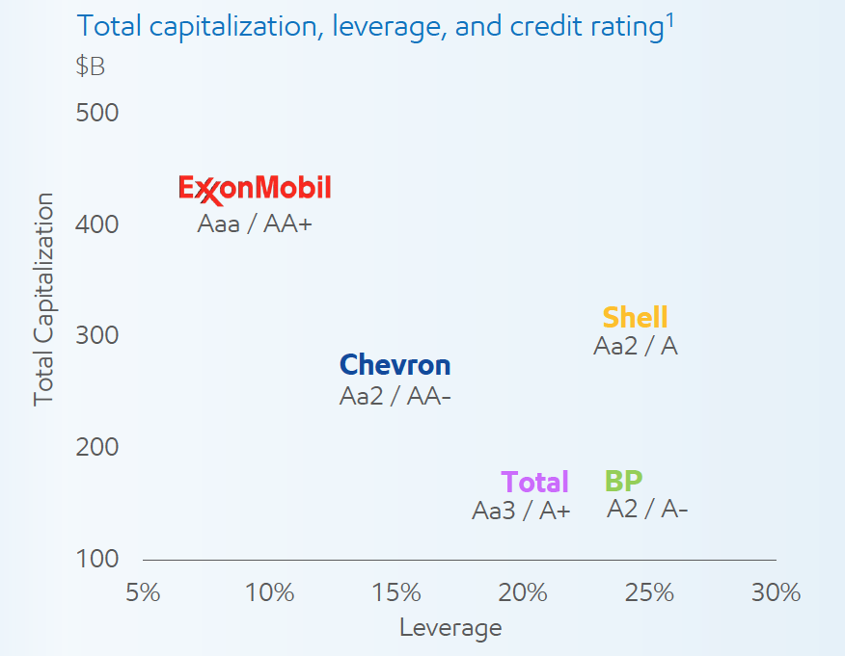

Further, XOM is the only major integrated oil company with positive cash flow in 2016. These two factors will allow XOM to continue to fund capital expenditures more aggressively than major competitors. Management presented a plan to fund capex in 2017 at $22 Billion versus $19 Billion in 2016.

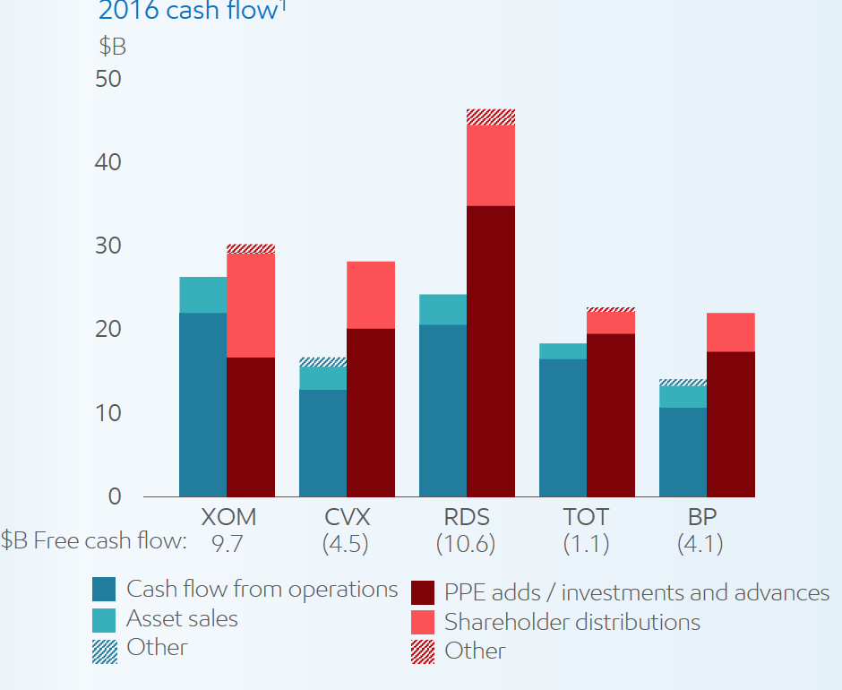

XOM provided details on the 2017 capital expenditure plan. Overall the plan emphasizes upstream investments both across short cycle and long cycle investments. 2017 will be more weighed towards long cycle projects with 2018 and beyond becoming more balanced particularly in the Permian and Bakken investments.

One area for concern to investors was management addressing the share repurchase program. Management indicated the repurchase program is a liquidity tool. As XOM looks at opportunities the initial measure is the level of accretion to the portfolio. Secondly, management is committed to the dividend and the lastly if there is excess liquidity it will deploy it in a share buyback. Concerning for an investor is that there was no explicit mention that share buybacks are weighed in lieu of portfolio investments if expected returns are higher.

Overall we view XOM shares with more optimism following the analyst meeting. The company is committed to maintain the dividend. XOM has the balance sheet and free cash flow to continue opportunistic investments as evidenced with its recent Bakkan acquisition.

