What to Really Do When You Haven’t Saved Enough for Retirement

Charles Rotblut of AAII Journal ([May 2017](http://www.aaii.com/journal/article/when-you-havent-saved-enough-for-retirement)) recently wrote an article for those savers who have not saved enough for retirement. I always agree that we all should save for retirement, and I support those who encourage those who have not to do so. I do disagree with many of the premises Mr. Rotblut assumes as he draws his conclusions. I will go through each one-by-one.

# Even at Age 50, You Still Have Time to Save

Rotblut assumes we have an average family that has saved nothing for retirement. That is a safe assumption. According to the Economic Policy Institute ([March 3, 2016](http://www.epi.org/files/2016/state-of-american-retirement-final.pdf)), nearly half of American households have not started saving for retirement, and that includes our average 50-year-old couple. No disagreements here.

Where I begin to disagree with Rotblut is his assumption that one should attempt to save with a $1 million goal in mind. Starting this goal at 50 is far harder than starting at 25. Rotblut even provides a chart to demonstrate what one has to do to achieve this goal.

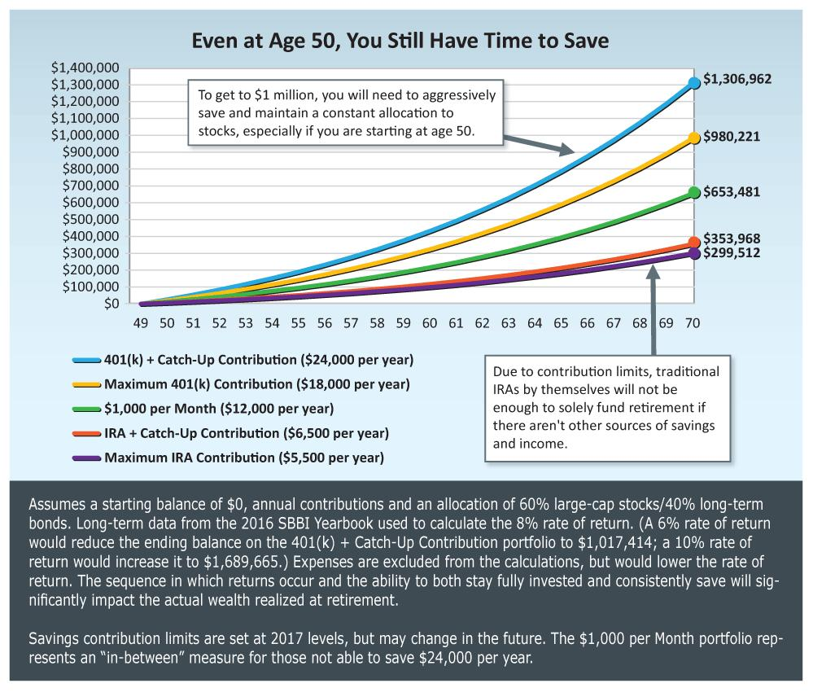

(From AAII)

I do not take issue with Rotblut’s math. It is correct. I take issue with his assumption about how much one can save.

According to Federal Reserve Bank of St. Louis ([Accessed 6/25/2017](https://fred.stlouisfed.org/series/MEHOINUSA672N)), the median household income is $56,516 per year; $65,000 for a typical 50-year old couple ([Census Bureau](https://www.census.gov/data/tables/time-series/demo/income-poverty/cps-hinc/hinc-02.html)). That assumes two adults. Throw in a child or two in the mix, and one can quickly see that budgets will be tight.

Now, looking at the chart above, the only path Rotblut provides the reader to the magical $1 million mark is by investing $24,000 per year for 20 ½ years. That is not realistic, and counterproductive. Anyone who has raised children, knows that if you want to shatter their motivation, tell them to do something that is impossible to achieve. Telling an average couple to set aside almost 40% of their earnings, and live on the rest will simply never happen. Since it won’t happen, then nothing will get done.

# How to Really Pay for This?

Because Rotblut does not recognize that the average household only has $65,000 in annual income, he is forgetting some special tax benefits that will help pay for a retirement plan. It is a credit that goes beyond reducing one’s taxable income, and even provides some pre-tax benefits for Roth IRAs. It is the Saver’s Tax Credit.

What is the Saver’s Tax Credit? You can read more about it [here](https://www.irs.gov/retirement-plans/plan-participant-employee/retirement-savings-contributions-savers-credit). Essentially, it is a refundable tax credit that benefits people who save for retirement in a traditional IRA, 401(k), 403(b), 457, SIMPLE IRA, and, SARSEP. It even provides tax benefits for those who save in a Roth IRA. Imagine that, even if one contributes to a Roth IRA, they can receive an immediate tax benefit.

The table below shows how much of a credit one receives, based on filing status and adjusted gross income (AGI). Notice that one can receive up 50% of their retirement contributions back as a refundable credit. All they have to do is complete [Form 8880](https://www.irs.gov/pub/irs-pdf/f8880.pdf), and enter the amount in the appropriate section on their 1040A or their 1040.

|  |  |  |  |
| --- | --- | --- | --- |
| **2017 Saver's Credit** | | | |
| **Credit Rate** | **Married Filing Jointly** | **Head of Household** | **All Other Filers\*** |
| 50% of your contribution | AGI not more than $37,000 | AGI not more than $27,750 | AGI not more than $18,500 |
| 20% of your contribution | $37,001 - $40,000 | $27,751 - $30,000 | $18,501 - $20,000 |
| 10% of your contribution | $40,001 - $62,000 | $30,001 - $46,500 | $20,001 - $31,000 |
| 0% of your contribution | more than $62,000 | more than $46,500 | more than $31,000 |

(From: IRS)

There are some caveats that need highlighting. First, only the first $2000 saved per individual is available for the credit. Second, the credit only takes affect if there were any federal withholdings, hence why the credit is refundable. Other than that, it is a pretty easy process.

What are the tax benefits? I will base my assumptions on out 50-year old couple with a joint income of $65,000. This is a pretty fair assumption. I will also assume there are no children in the household.

Let’s say the couple is saving 10% of their gross earnings. This is what their tax results will look like

|  |  |
| --- | --- |
| Wages, Salaries, Tips, etc. | $65,000 |
| IRA Deduction | -6,500 |
| Adjusted Gross Income | 58,500 |
| Standard Deduction | -12,600 |
| Exemptions | -8,100 |
| Taxable Income | 37,800 |
| Taxes Owed | 4,746 |
| Saver’s Credit | -400 |
| Final Tax Obligation | 4,346 |

Now compare that to the couple who does nothing:

|  |  |
| --- | --- |
| Wages, Salaries, Tips, etc. | $65,000 |
| IRA Deduction | -0 |
| Adjusted Gross Income | 65,000 |
| Standard Deduction | -12,600 |
| Exemptions | -8,100 |
| Taxable Income | 44,300 |
| Taxes Owed | 5,721 |
| Saver’s Credit | -0 |
| Final Tax Obligation | 5,721 |

As one can clearly see, the tax advantages of the IRA deduction and the saver’s credit amount to a difference of $1,375 in taxes owed. As I tell my clients, it will only cost them $5,125 to save $6,500. Throw in a 401(k) match, and it only costs them $5,125 to save $13,000.

# Allocation

Rotblut assumes a 60/40 allocation of large cap equities and long-term bonds. For the investor who is just getting started, and needs to accumulate as much savings as possible, this is far too conservative, and is demonstrated by the allocation’s 8% annual return.

First, if one is going to invest in equities, they will need to add mid- and small-cap companies to their holdings. They will also need to go beyond our borders, and add international stocks to their allocation too. I suggest a different, and more aggressive allocation. It might look something like this:

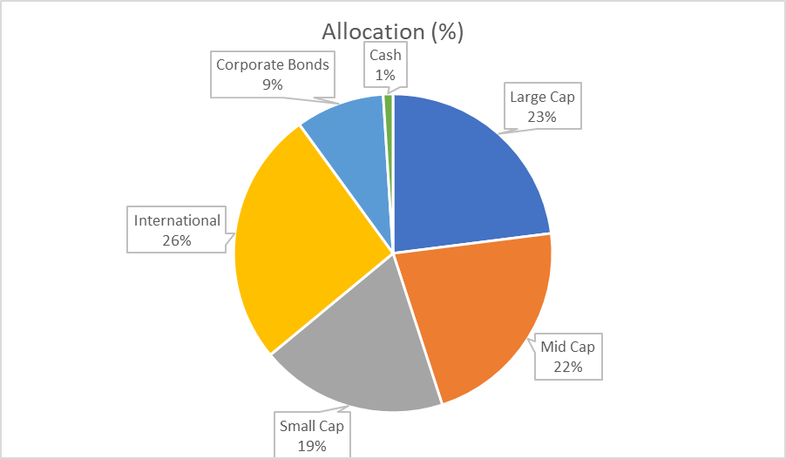

Using data from Ibbotson ([2013](http://www.healthinquiry.net/Public%20Submissions/Netcare%20Ex%20GH-75%20Ibbotson.pdf)) MSCI ([Accessed: 06/25/2017](https://www.msci.com/equity-fact-sheet-search)), this approach historically returns 9.67% per year. That will certainly help one achieve the goal approaching $1 million. Why is this a big deal? A 9.67% annual return will yield a lot more than 8%, and if our goal is to get as close to $1 million, then one would need to take more risk to get there.

But is it really risky? Not for a 20-year period. According to data from Robert Shiller ([Accessed: 06/28/2017](http://www.econ.yale.edu/~shiller/data/ie_data.xls)), there has never been a 20-year period since 1871 where investing in an all equity portfolio has lost money. While a 50-year old investor does not have the same timeframe as a 25-year old, 20 years is still a pretty long period in which to grow one’s assets. Add in that investing does not stop at 70, but will go well beyond that, maybe even 30 years, and that leaves us with a 50-year time-horizon.

Putting all of this together, and if our couple can increase their contributions at 2.95%, our couple could be looking at a portfolio worth $466,213, $932,426 if they were matched in a 401(k).

# Final Thoughts

Here is the key point that is missing from many of these conversations. Even if our investors just started with $4,000 per year, so they can take full advantage of the saver’s credit, they would still have around $297,000 in their accounts. That still provides them with around $15,000 in initial retirement income, and that is $15,000 more than if they had done nothing. By the way, I do use the 5% rule for retirement withdrawals, especially in a low inflation environment like ours.

Here is a chart showing the effect of time and growth on a $100/month systematic investment plan. Please note, that it assumes a 3% annual increase in the contributions. If you want to invest a higher amount, just divide by 100 and multiply by the amount you want.

|  |  |  |  |  |  |  |  |  |
| --- | --- | --- | --- | --- | --- | --- | --- | --- |
| Future Value of Systematic Investment Plan | | | | | | | | |
|  | Growth Rate | | | | | | | |
| Time |  | 6% | 7% | 8% | 9% | 10% | 11% | 12% |
| 40 | 280,947 | 351,373 | 443,100 | 562,948 | 719,952 | 926,082 | 1,197,186 |
| 35 | 194,889 | 235,882 | 287,316 | 352,002 | 433,518 | 536,415 | 666,477 |
| 30 | 132,649 | 155,550 | 183,249 | 216,808 | 257,522 | 306,976 | 367,102 |
| 25 | 87,924 | 100,010 | 114,113 | 130,586 | 149,844 | 172,375 | 198,750 |
| 20 | 56,041 | 61,907 | 68,516 | 75,966 | 84,367 | 93,843 | 104,536 |
| 15 | 33,544 | 36,032 | 38,741 | 41,690 | 44,902 | 48,399 | 52,208 |
| 10 | 17,877 | 18,697 | 19,560 | 20,469 | 21,426 | 22,433 | 23,492 |
| 5 | 7,158 | 7,298 | 7,441 | 7,587 | 7,735 | 7,887 | 8,041 |

If you really want to show off, here is the formula. It will allow you to use any initial amount, growth rate, and inflation rate you want. Enjoy!



For financial advisors, it is important to understand that people come to us at different starting points. There is a majority of our population who are starting with nothing. We have a fiduciary obligation, even a moral obligation, to help these people. If our couple does nothing, they will only receive around $6,400 per month in Social Security retirement benefits. That assumes they will wait until they are 70 to retire. If they retire at 67, then their income drops to $4,620 per month. I used the Social Security Quick Calculator. If you are interested, you can find it [here](https://www.ssa.gov/oact/quickcalc/).

They cannot just depend on Social Security for their retirement. It will not be enough, and the days of a pension waiting for us are gone. Instead of telling them they will not have enough money if they do not reach $1 million. We should start with the conversation that $0 is not enough, and the more they can do, then the better they will be later.

While the average (mean) 50-year old couple who has been saving for retirement already has around $220,000, and they are well on their way to a comfortable retirement, we need to help those who have not started. It is possible they will only have $220,000 when they retire, but that is still better than where they were. Given that our couple was looking at $3,200/month in today’s dollars in social security retirement benefits, increasing their retirement income by any amount will make their lives easier.

I hope this helps, and

Happy Investing!