Survey Strength Is Not Resulting In Economic Strength

This is a weekly series focused on analyzing the previous week’s economic data releases

Our objective is to identify what are leading indicators of economic activity in hopes of gaining insight as to whether the economy is strengthening or weakening

This week we examine auto sales, factor orders, construction spending, the ISM and PMI manufacturing and services surveys, as well as the jobs report for June

The surveys of economic activity continue to be much stronger than the real economic data points

**Auto Sales**

Consumers may say they are confident, but their enthusiasm for buying new cars is waning rapidly. Sales declined 1.7% on a year-over-year basis in June to a seasonally adjusted annual rate of 16.51 million, which is a new low for the year. Domestic auto sales for June declined 14.6% below last year’s number. As I previously mentioned, inventories rose above 70 days in May for the first time since 2009, and incentives continue to increase, rising 9.7% above year-ago levels in June. Those more optimistic about the economy will say that the current rate of sales is still strong, but economics is about the rate of change, which continues to erode after achieving a peak sales rate for this cycle of more than 18 million autos per year in 2016.

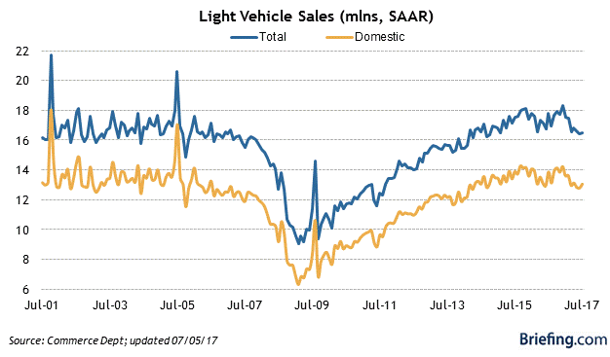

**Factory Orders**

Factory orders measure the change in dollar value for both durable and non-durable goods orders, updating the most recent durable goods report with more information. Factory orders declined 0.8% in May, and April’s decline of 0.2% was revised lower to 0.3%. Orders for durables and non-durables were both lower by 0.8%. A double-digit decline in aircraft orders (commercial and defense) weighed heavily on the May number, but there was a 1.2% increase in orders for motor vehicles and parts. Yet this only adds to what are already bloated inventories, which will depress future orders in this category.

On a positive note, when we exclude the transportation and defense sectors, core capital goods orders (business investment) rose 0.2% in May, and the shipments of these goods, which is used to compute GDP, rose 0.1%. Still, there is nothing here to indicate an acceleration in the rate of economic growth.

[**https://www.census.gov/manufacturing/m3/prel/pdf/s-i-o.pdf**](https://www.census.gov/manufacturing/m3/prel/pdf/s-i-o.pdf)

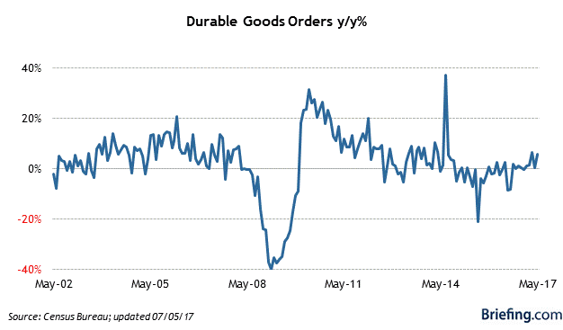

**Construction Spending**

The construction spending report includes the total value of all new construction activity for residential, non-residential and public projects. Overall construction spending was flat in May, following a 0.7% decline in April. Residential housing construction was particularly weak, having declined 0.6%, which is in line with the weak permits data reported in prior months. Considering strong demand, rising prices and limited supply, it is hard to understand why residential construction is not ramping up. The lack of new residential construction, particularly at the low end, will lead to continued price increases, which will negatively impact demand.

<https://www.census.gov/construction/c30/about_the_survey.html>

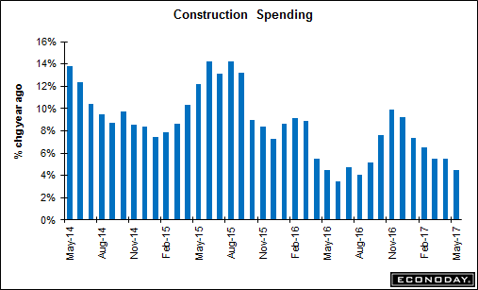

**ISM and PMI Manufacturing Index**

The Institute for Supply Management’s manufacturing index, which registered a very strong reading of 57.8 for June, has been indicating an acceleration in the rate of growth for months. It hasn’t happened yet, and it reminds me of strengthening consumer confidence levels that have yet to translate into an acceleration in the rate of consumer spending growth.

The June survey showed big increases in new orders, production and employment in June. The ISM suggests that this level of manufacturing activity is consistent with a rate of economic growth of 4.6%, based on historical survey results and GDP figures, which is laughable. I have yet to determine why there is just a significant disconnect between the survey results and the hard data that has followed. The only explanation that seems plausible is that purchasing managers continue to expect fiscal stimulus measures out of Washington, but that seems increasingly unlikely as the end of fiscal 2017 approaches.

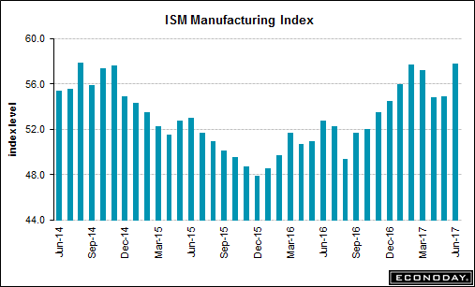

<https://www.instituteforsupplymanagement.org/ismreport/mfgrob.cfm>

Markit’s PMI Manufacturing index is far more consistent with the hard data than the ISM report, **declining** for a fifth month in a row in June to 52.0. This survey shows orders rising at their slowest pace in nine months with export orders particularly weak. While still indicating expansion, the rate of growth is weakening. The Chief Business Economist at Markit, Chris Williamson, described the June survey results for the manufacturing sector as “stagnation – at best.”

https://www.markiteconomics.com/Survey/Page.mvc/PressReleases



**ISM and Markit Services Indices**

The Institute for Supply Management’s service sector index compiles survey results from approximately 375 companies representing a wide variety of service-sector industries. This survey also continues to report stronger results than the actual rate of economic growth being realized, based on the historical relationship between the index and GDP.

Survey results led to a robust index reading of 57.4 for June, up from May’s reading of 56.9, led by an uptick in new orders (both domestic and export). The index corresponds with a rate of economic growth that is better than 3%, but this continues to look very unlikely. All that I can discern from the survey results is that the services sector is much stronger than the manufacturing sector, which is important from the standpoint that it represents a much larger percentage of the economy.

<https://www.instituteforsupplymanagement.org/ismreport/nonmfgrob.cfm>

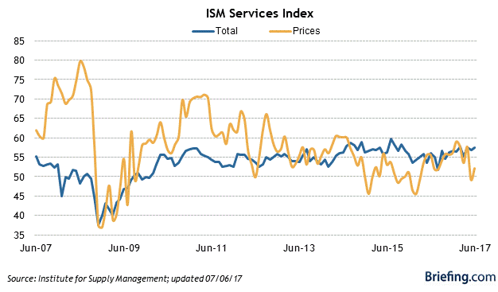

Markit’s PMI Services index **rose** to 54.2 in June from May’s reading of 53.6. The rise in backlogs we saw in prior months led to the strongest increase in business activity since January. New order growth was also at a five-month high. This index is closing out the second quarter with business activity down very modestly from the first-quarter level, which Markit suggests is consistent with an approximate 2% rate of annualized economic growth.

<https://www.markiteconomics.com/Survey/Page.mvc/PressReleases>

**The Jobs Report**

The Bureau of Labor Statistics **estimated** that 222,000 new jobs were created in June, but what investors really liked were the 47,000 additional jobs that resulted from upward revisions to the prior two disappointing months. The reality is that we have seen four consecutive downward revisions between the initial estimate and the second revision to that estimate, including the one for April that was interpreted as good news last week. This implies that new businesses and jobs that the BLS assumes are being created, but which are too new to be included in its survey results, are not being created!

https://www.bls.gov/news.release/empsit.nr0.htm

The most important number in the jobs report is the one that receives the least amount of attention—wage growth. Growth in average hourly earnings was unchanged at a 2.5% on a year-over-year basis, while last month’s increase was revised lower to 2.4%. It is hard to believe that we have near full employment and a strong labor market with virtually no real income growth. Real income growth is the fuel that drives the US economy.

